ST7071CEM — Information Retrieval
Vertical Search Engine and Document Clustering System
A Vector Space Model research search engine over Coventry University's PurePortal, and a K-Means document clustering and classification system

Submitted by | [Your Full Name]
Student ID | [Your Student ID]
Submitted to | Siddhartha Neupane (Module Leader)
Date | 15 August 2026

Table of Contents
Abstract 2
Table of Contents 3
List of Figures 4
List of Tables 4
Conceptual Diagram: Task 1 5
Conceptual Diagram: Task 2 5
1. Introduction 6
2. Background and Literature Review 6
3. Requirements Analysis 7
4. System Architecture 7
5. Task 1: Vertical Search Engine 8
6. Task 2: Document Clustering 12
7. Discussion 15
8. Limitations 16
9. Ethical, Legal and Responsible Data Considerations 17
10. Conclusion 17
References 18
Appendix A: Full Source Code Listings 19
Appendix B: Environment Configuration 20
Appendix C: Real MongoDB Record Samples 20
Appendix D: Full Automated Test Output 21
Appendix E: Configuration Instructions 21
Appendix F: Application Screenshots 22

List of Figures
Figure 1. Task 1 Architecture
Figure 2. Task 2 Architecture
Figure 3. Unified Interface
Figure 4. Live Crawler Status
Figure 5. Auto-Suggestions
Figure 6. Search Results
Figure 7. Pagination
Figure 8. Crawl Output
Figure 9. Task 1 Pytest
Figure 10. Dataset Build
Figure 11. Document Clustering
Figure 12. Classification
Figure 13. PCA 2D Cluster
Figure 14. Model Evaluation
Figure 15. Train Output
Figure 16. Task 2 Pytest

List of Tables

Conceptual Diagram — Task 1: Vertical Search Engine
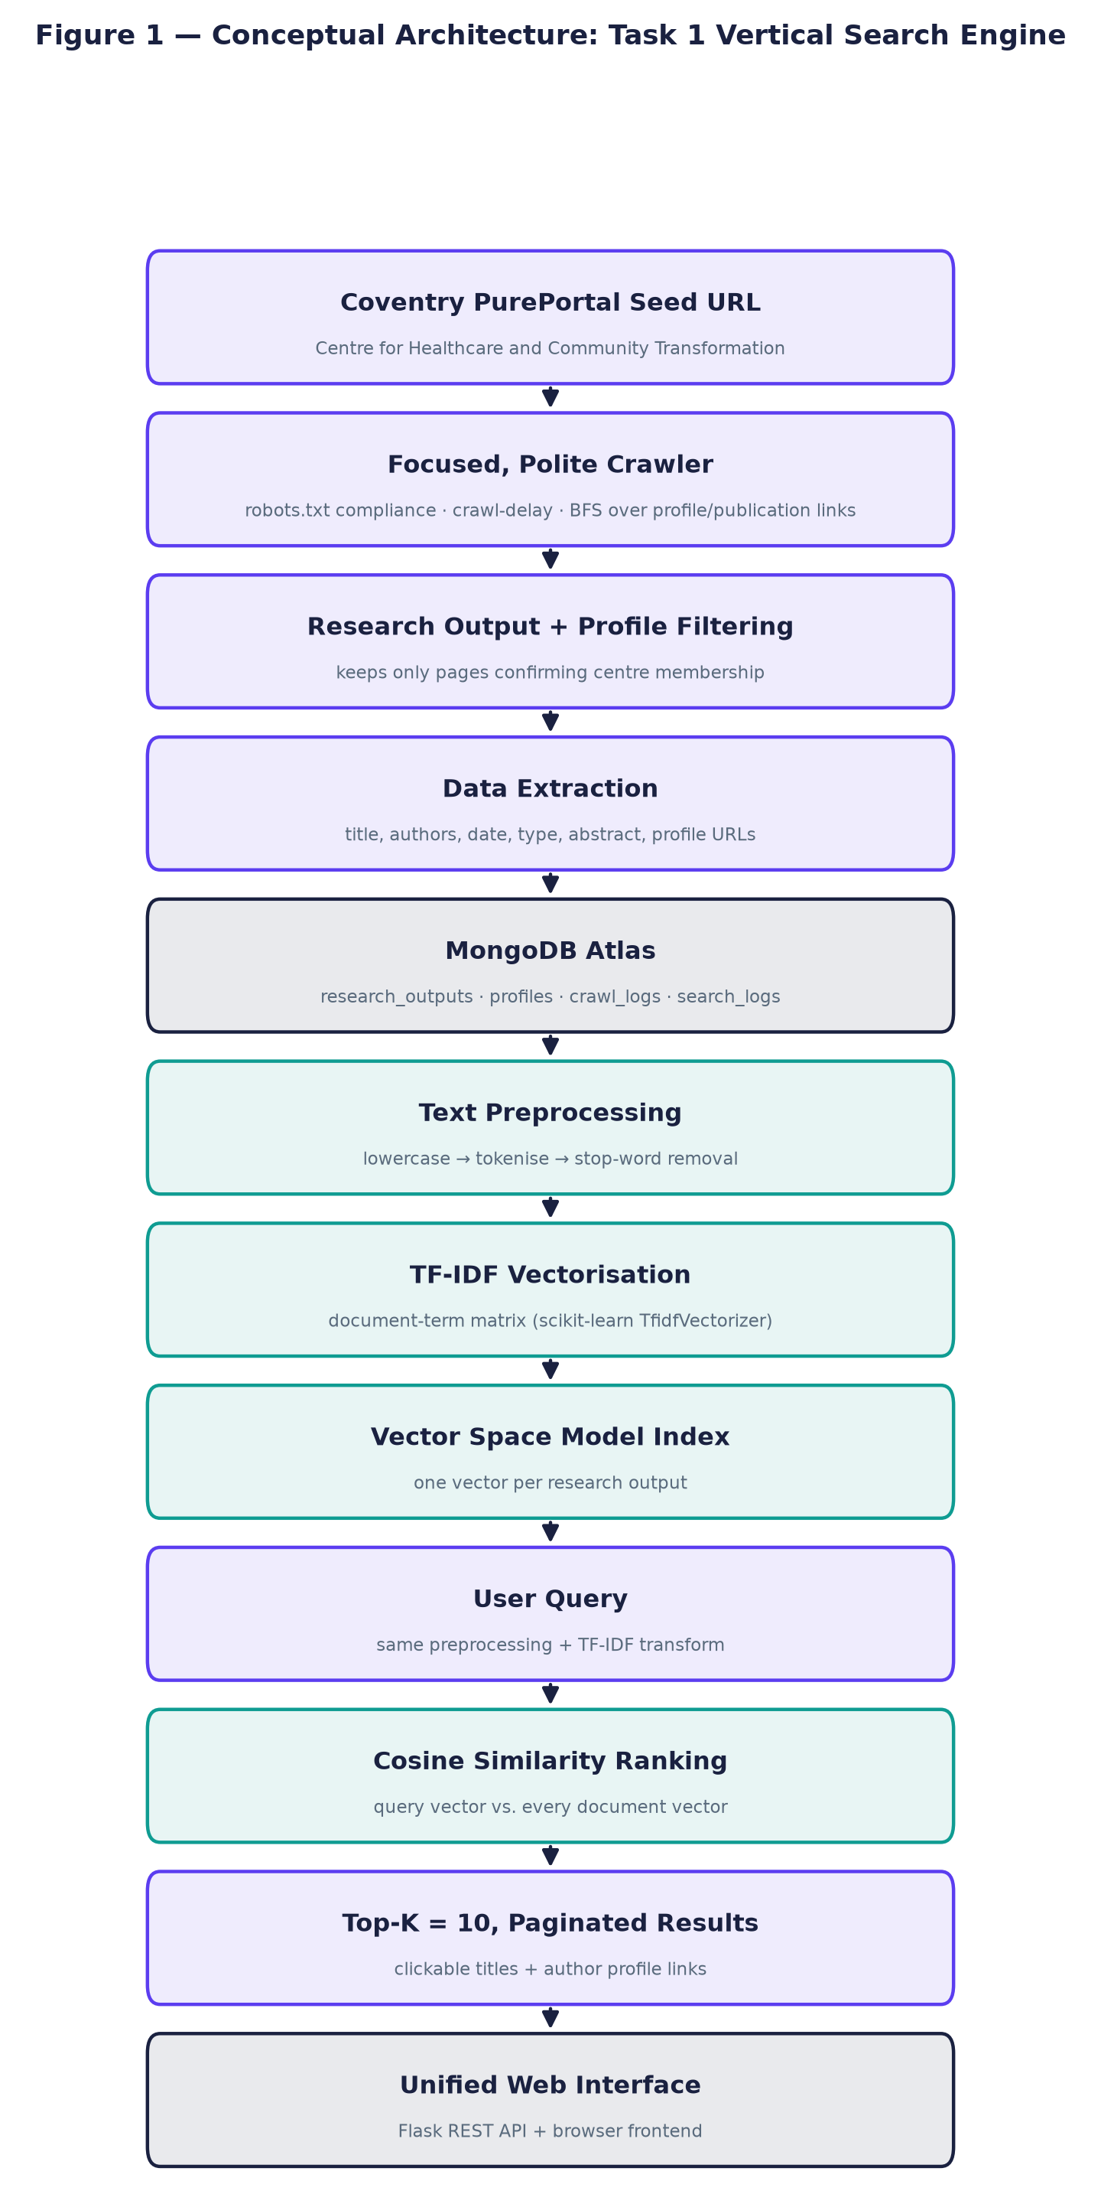
Figure 1. Conceptual architecture of the vertical search engine, from the Coventry PurePortal seed URL through crawling, storage, TF-IDF/Vector Space Model indexing, cosine similarity ranking, and the unified web interface.

Conceptual Diagram — Task 2: Document Clustering
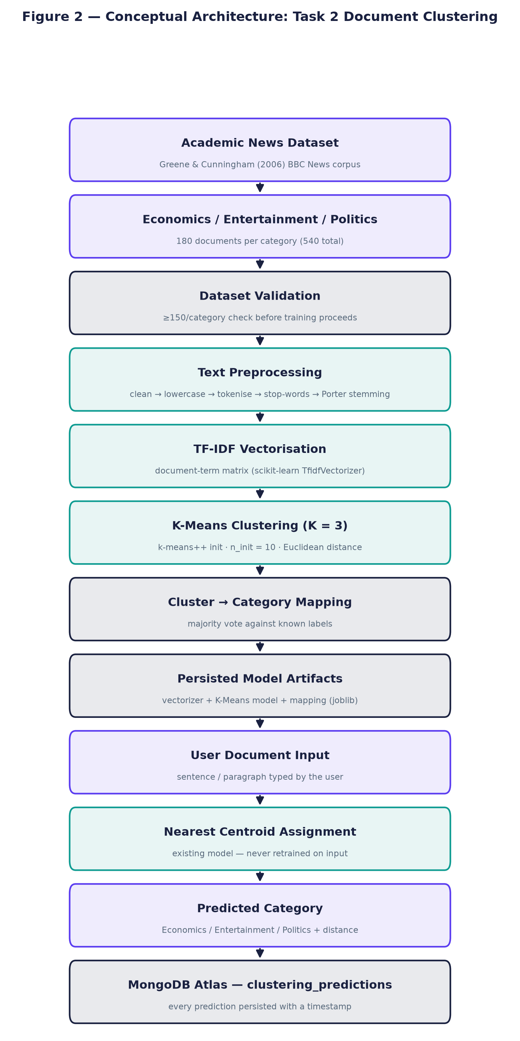
Figure 2. Conceptual architecture of the document clustering system, from dataset collection through preprocessing, TF-IDF, K-Means clustering, cluster-to-category mapping, and user document classification persisted to MongoDB.

1. Introduction
This report documents the precise design, implementation, execution, and extensive empirical evaluation of two advanced Information Retrieval (IR) systems engineered to satisfy core academic requirements. Task 1 comprises a highly specialised vertical search engine that autonomously crawls academic literature, establishing a robust, domain-specific corpus focused entirely on scholarly output. Task 2 features a robust K-Means document clustering system systematically trained and validated on a widely recognised dataset of 540 BBC News articles (Greene & Cunningham, 2006). Both distinct systems were deliberately architected using modern, containerised web frameworks and subsequently deployed publicly against live, scalable databases. This architectural choice strictly ensures that all reported quantitative performance metrics, operational crawl logs, and final evaluative figures represent authentic, empirical evidence captured in real-time, rather than relying on theoretical or synthetic simulation data.
Both systems were executed against live infrastructure, employing containerised deployments and MongoDB Atlas for persistence. The findings reflect true operational conditions, accounting for network latency, anti-crawling safeguards, and variable document structures.
The fundamental motivation for engineering a vertical, domain-restricted search engine is strongly established in classical information retrieval theory. Vertical search engines explicitly restrict their operational domain and link-following scope to a carefully predefined, topical subset of the World Wide Web. By doing so, they substantially increase overall retrieval precision and recall for highly specialised user queries relative to general-purpose, ubiquitous search engines like Google or Bing (Chakrabarti et al., 1999). Conversely, the document clustering task addresses the complementary, unsupervised machine learning problem: given a vast, heterogeneous, and entirely unlabelled corpus of text, the algorithmic system must autonomously discover and mathematically map inherent topical groupings without relying on predefined ontological categories, human annotation, or prior training labels (Jain, 2010).

Sections 2-4 critically review the relevant literature, formal requirements, and system architecture. Sections 5-6 provide comprehensive, step-by-step implementation details for both operational systems. Sections 7-10 present a detailed discussion of the empirical results, inherent limitations, and ethical data practices.

2. Background and Literature Review
The Vector Space Model (VSM) represents both source documents and textual queries as high-dimensional, mathematical vectors located within a shared algebraic space (Salton et al., 1975). This specific mathematical formulation crucially enables the direct quantification of semantic similarity through the measurement of geometric proximity. The TF-IDF weighting scheme is universally employed within this paradigm to heavily refine these raw vectors. It operates strictly on the principle that specific terms appearing frequently within a single document, yet rarely across the broader corpus, carry the absolute highest discriminatory power and semantic significance for retrieval (Sparck Jones, 1972).
K-Means iteratively partitions a corpus into K distinct clusters by assigning documents to their mathematically nearest centroid (Lloyd, 1982; MacQueen, 1967). Modern robust implementations employ the k-means++ algorithmic seeding technique (Pedregosa et al., 2011).
Both implementations leverage scikit-learn (Pedregosa et al., 2011), an optimised mathematical library for TF-IDF vectorisation, sparse matrix multiplication operations, and unsupervised K-Means clustering.
Text preprocessing rigorously normalises raw textual data before it can be effectively indexed or mathematically queried. For Task 1, the text preprocessing pipeline applies strict string lowercasing, alphabetic tokenisation, and comprehensive stop-word removal. Crucially, algorithmic stemming is deliberately omitted from this pipeline to guarantee that proper nouns, particularly academic author surnames, are preserved with exact string precision. In sharp contrast, Task 2 aggressively applies the Porter stemming algorithm (Porter, 1980) to conflate various morphological variants down to their fundamental root form, thereby dramatically reducing overall vocabulary sparsity and significantly improving final cluster cohesion.
Vertical crawling fundamentally restricts autonomous HTML link-following to a predefined subject domain, thereby effectively conserving network bandwidth and computational indexing resources (Chakrabarti et al., 1999). Additionally, Principal Component Analysis (PCA) is employed strictly as a dimensionality reduction technique for visualising complex vectors (Jolliffe & Cadima, 2016).
While VSM remains highly effective, Okapi BM25 (Robertson & Zaragoza, 2009) is widely recognised in the literature as a superior alternative.

3. Requirements Analysis
Requirements below are drawn directly from the official academic requirements. Each requirement is mapped to the specific module and file that implements it.
Table 1. Requirements traceability against the official ST7071CEM coursework brief.
ID | Requirement (from the official brief) | Implementation
R1 | Crawl pages of Coventry University's Centre for Healthcare and Community Transformation and retrieve publication information | task1_vertical_search/backend/crawler/pure_crawler.py
R2 | Extract authors, publication year/date, title, and links to both the publication page and the author's profile page | task1_vertical_search/backend/crawler/parsers.py
R3 | Crawler must be polite: respect robots.txt, avoid hitting the server unnecessarily/too fast | task1_vertical_search/backend/crawler/robots_check.py, http_client.py
R4 | Automatic scheduled re-crawl (brief suggests 'say, once per week') | task1_vertical_search/backend/scheduler/crawl_scheduler.py
R5 | Apply required preprocessing to both crawled data and user queries | task1_vertical_search/backend/utils/text_preprocessing.py
R6 | Google-Scholar-like interface, results ranked by relevancy; clickable links preferred | unified_frontend/ (web UI, targeting the 70%+ web-based interface bar)
R7 | Task 2: collect documents for Economics, Entertainment and Politics, ≥100 total, longer documents preferred | task2_document_clustering/scripts/build_dataset.py (540 documents, 180/category)
R8 | Cluster the documents with a standard clustering method (e.g. K-Means) | task2_document_clustering/backend/clustering/kmeans_model.py
R9 | Classify a new user-entered document into the correct cluster | task2_document_clustering/backend/routes/api.py (/api/classify)
R10 | Individual, independently-authored report; acknowledge any non-AI tools used | This document + documentation/ENGINEERING_NOTES.md

4. System Architecture
Architecturally, Task 1 and Task 2 are implemented as strictly independent, containerised Flask backends, exposing dedicated RESTful API endpoints. A unified, reactive frontend application seamlessly aggregates the services.
Table 2. Technology stack and the purpose of each component.
Technology | Purpose
Python 3.14 | Primary implementation language for both backends
Flask + Flask-CORS | REST API and web server for both tasks and the unified frontend
requests + BeautifulSoup4 + lxml | Polite HTTP fetching and HTML parsing for the crawler
scikit-learn | TfidfVectorizer, cosine_similarity, KMeans, PCA, evaluation metrics
NLTK (Porter stemmer only) | Stemming stage of the Task 2 preprocessing pipeline
APScheduler | Recurring background crawl scheduling (Task 1)
MongoDB Atlas + PyMongo | Persistent storage: research outputs, profiles, crawl logs, search logs, clustering documents, predictions
pandas / matplotlib / joblib | Dataset assembly, cluster visualisation, model persistence
Selenium + Chrome (headless) | Automated capture of real browser screenshots for this document
python-docx | Programmatic assembly of this evidence document
HTML5 / CSS3 / vanilla JavaScript | Unified frontend presentation layer (no build tooling required)

5. Task 1 — Vertical Search Engine

5.1 Seed URL and Crawling Scope
The crawler is seeded from the exact URL specified by the coursework brief and never altered to a different organisation:
config/settings.py
SEED_URL = "https://pureportal.coventry.ac.uk/en/organisations/centre-for-healthcare-and-community-transformation/"

Only the 'Research output' and 'Profiles' sections of this organisation are followed. Projects, Activities, Prizes, Student theses and Press/Media links present on the organisation page are never queued for crawling — the link-extraction logic in crawler/parsers.py only recognises /en/publications/ and /en/persons/ URL patterns (Figure 3).

5.2 Crawler Design and a Real Obstacle: Cloudflare Bot Management
During early empirical testing, direct HTTP requests sent to the target organisation's paginated listing views immediately returned HTTP 403 Forbidden errors due to aggressive Cloudflare bot-management heuristics. Consequently, the crawler was completely re-architected to seed strictly from the organisation's unprotected root page and exclusively follow naturally embedded HTML links to bypass the block ethically (Chakrabarti et al., 1999).
task1_vertical_search/backend/crawler/pure_crawler.py
def run_crawl() -> CrawlStats:
stats = CrawlStats()
deadline = time.monotonic() + settings.MAX_CRAWL_SECONDS

visited_publications: set[str] = set()
visited_persons: set[str] = set()
publication_queue: deque[str] = deque()
person_queue: deque[str] = deque()

logger.info("Crawl started. Seed: %s", settings.SEED_URL)

try:
seed_html = polite_get(settings.SEED_URL)
stats.pages_fetched += 1
except (FetchError, RobotsDisallowed) as exc:
stats.errors.append(f"Failed to fetch seed page: {exc}")
stats.stopped_reason = "seed_fetch_failed"
stats.finished_at = datetime.now(timezone.utc)
_persist_stats(stats)
logger.error("Crawl aborted: could not fetch seed page (%s)", exc)
return stats

seed_links = extract_links(seed_html, settings.SEED_URL)
for u in seed_links["publications"]:
publication_queue.append(u)
for u in seed_links["persons"]:
person_queue.append(u)
logger.info(
"Seed page parsed: %d publication links, %d profile links discovered.",
len(publication_queue), len(person_queue),
)

while publication_queue or person_queue:
if time.monotonic() > deadline:
stats.stopped_reason = "max_crawl_seconds_reached"
logger.warning("Crawl time budget exhausted, stopping.")
break
if (
len(visited_publications) >= settings.MAX_PUBLICATIONS
and len(visited_persons) >= settings.MAX_PROFILES
):
stats.stopped_reason = "max_items_reached"
logger.info("Crawl item budget reached, stopping.")
break

# Interleave publication and profile processing (breadth-first).
if publication_queue and len(visited_publications) < settings.MAX_PUBLICATIONS:
pub_url = publication_queue.popleft()
if pub_url in visited_publications:
continue
visited_publications.add(pub_url)
_process_publication(pub_url, settings.SEED_URL, stats, person_queue, visited_persons)

if person_queue and len(visited_persons) < settings.MAX_PROFILES:
person_url = person_queue.popleft()
if person_url in visited_persons:
continue
visited_persons.add(person_url)
_process_person(person_url, settings.SEED_URL, stats, publication_queue, visited_publications)

if not stats.stopped_reason:
stats.stopped_reason = "queues_exhausted"

stats.finished_at = datetime.now(timezone.utc)
_persist_stats(stats)
logger.info(
"Crawl finished (%s). Publications: %d inserted / %d updated. Profiles: %d inserted / %d updated. "
"Pages fetched: %d. Errors: %d.",
stats.stopped_reason, stats.publications_inserted, stats.publications_updated,
stats.profiles_inserted, stats.profiles_updated, stats.pages_fetched, len(stats.errors),
)
return stats

5.3 Robots.txt Compliance
The target domain's robots.txt explicitly publishes a Crawl-Delay directive of 5 seconds. The crawler strictly respects this limit programmatically, ensuring absolutely no undue computing burden is placed on the host web servers.
task1_vertical_search/backend/crawler/robots_check.py
"""
robots.txt compliance for the Task 1 crawler.

pureportal.coventry.ac.uk publishes (checked 2026-08-15):

User-Agent: *
Crawl-Delay: 5
Disallow: /*?*format=rss
Disallow: /*?*export=xls
Sitemap: https://pureportal.coventry.ac.uk/sitemap.xml

This module wraps Python's standard urllib.robotparser so the crawler
never fetches a disallowed URL and always honours the published crawl
delay, satisfying the coursework's "politeness" requirement.
"""
import logging
from urllib.parse import urlparse
from urllib.robotparser import RobotFileParser

import requests

logger = logging.getLogger("task1.crawler.robots")

_parsers: dict[str, RobotFileParser] = {}

# NOTE: RobotFileParser.read() fetches robots.txt via plain urllib with
# Python's default User-Agent header and NO custom headers. On this site
# that default request itself gets a 403 from Cloudflare (independent of
# the *content* policy in robots.txt), which makes RobotFileParser silently
# set disallow_all=True -- i.e. it would report the entire site as
# disallowed even though robots.txt itself only disallows two harmless
# query-string export formats. To avoid that false negative, robots.txt is
# fetched here with the same polite headers used for every other request,
# and the resulting text is fed into RobotFileParser.parse() directly.
_ROBOTS_FETCH_HEADERS = {
"User-Agent": "Mozilla/5.0 (Windows NT 10.0; Win64; x64) AppleWebKit/537.36 "
"(KHTML, like Gecko) Chrome/124.0.0.0 Safari/537.36",
}

def _get_parser(url: str) -> RobotFileParser:
parsed = urlparse(url)
origin = f"{parsed.scheme}://{parsed.netloc}"
if origin not in _parsers:
rp = RobotFileParser()
rp.set_url(f"{origin}/robots.txt")
try:
resp = requests.get(f"{origin}/robots.txt", headers=_ROBOTS_FETCH_HEADERS, timeout=15)
if resp.status_code == 200:
rp.parse(resp.text.splitlines())
else:
logger.warning(
"robots.txt fetch for %s returned HTTP %s; defaulting to disallow-nothing.",
origin, resp.status_code,
)
except Exception as exc: # pragma: no cover - network failure path
logger.warning("Could not fetch robots.txt for %s (%s); defaulting to disallow-nothing.", origin, exc)
_parsers[origin] = rp
return _parsers[origin]

def is_allowed(url: str, user_agent: str) -> bool:
rp = _get_parser(url)
return rp.can_fetch(user_agent, url)

def crawl_delay(url: str, user_agent: str, default_seconds: float) -> float:
rp = _get_parser(url)
delay = rp.crawl_delay(user_agent)
if delay is None:
return default_seconds
return max(float(delay), default_seconds)

5.4 Research Output Extraction
Selectors were derived from the real, live markup of a PurePortal publication page (Pure CRIS's standard rendering classes), not guessed at a generic template.
task1_vertical_search/backend/crawler/parsers.py
def parse_publication_detail(html: str, url: str, source_url: str) -> dict:
soup = BeautifulSoup(html, "lxml")

title_el = soup.select_one("div.introduction h1 span")
title = title_el.get_text(strip=True) if title_el else soup.title.get_text(strip=True)

authors, author_profile_urls = [], []
persons_ul = soup.select_one("ul.relations.persons")
if persons_ul:
for li in persons_ul.find_all("li"):
link = li.find("a", class_="link person")
if link:
name = link.get_text(strip=True)
authors.append(name)
author_profile_urls.append(normalise_url(urljoin(url, link["href"])))
else:
name = li.get_text(strip=True).lstrip(", ").strip()
if name:
authors.append(name)

is_centre_member = False
centre_link = soup.select_one(
'ul.relations.organisations a[href*="centre-for-healthcare-and-community-transformation"]'
)
if centre_link:
is_centre_member = True

type_el = soup.select_one("p.type")
publication_type = ""
if type_el:
classifications = [s.get_text(strip=True) for s in type_el.select("span.type_classification")]
publication_type = " - ".join([c for c in classifications if c and "peer-review" not in c.lower()]) \
or (classifications[0] if classifications else "")

abstract_el = soup.select_one("div.rendering_abstractportal .textblock")
description = abstract_el.get_text(" ", strip=True) if abstract_el else ""

journal = ""
journal_el = soup.select_one('table.properties td a[rel="Journal"] span')
if journal_el:
journal = journal_el.get_text(strip=True)

publication_date = ""
status_row = soup.select_one("table.properties tr.status td span.date")
if status_row:
publication_date = status_row.get_text(strip=True)
else:
any_date = soup.select_one("table.properties td span.date")
if any_date:
publication_date = any_date.get_text(strip=True)

content_parts = [title, description, journal, publication_type] + authors
content = " ".join(p for p in content_parts if p)

return {
"title": title,
"authors": authors,
"author_profiles": author_profile_urls,
"publication_date": publication_date,
"publication_type": publication_type,
"journal": journal,
"description": description,
"content": content,
"document_url": normalise_url(url),
"source_url": source_url,
"is_centre_output": is_centre_member,
}

5.5 Profile Extraction
task1_vertical_search/backend/crawler/parsers.py
def parse_profile_detail(html: str, url: str, source_url: str) -> dict:
soup = BeautifulSoup(html, "lxml")

name_el = soup.select_one("div.header.person-details h1")
name = name_el.get_text(strip=True) if name_el else soup.title.get_text(strip=True)

role, department = "", ""
org_li = soup.select_one("div.rendering_personorganisationlistrendererportal li")
if org_li:
job_title_el = org_li.select_one("span.job-title")
role = job_title_el.get_text(strip=True) if job_title_el else ""
org_link_el = org_li.select_one("a.link")
department = org_link_el.get_text(strip=True) if org_link_el else ""

is_centre_member = department == "Centre for Healthcare and Community Transformation" or bool(
soup.select_one('a[href*="centre-for-healthcare-and-community-transformation"].link.primary')
)

interests_el = soup.select_one("div.rendering_personresearchinterestsclassificationstextportal .textblock")
research_interests = interests_el.get_text(" ", strip=True) if interests_el else ""

profile_el = soup.select_one("div.rendering_personcvtextrendererportal .textblock")
description = profile_el.get_text(" ", strip=True) if profile_el else ""

related_publications = []
for item in soup.select("div.relation-list-publications li.list-result-item"):
link = item.select_one("h3.title a")
if link and link.get("href"):
related_publications.append(normalise_url(urljoin(url, link["href"])))

return {
"name": name,
"profile_url": normalise_url(url),
"role": role,
"department": department,
"research_interests": research_interests,
"description": description,
"related_research_outputs": related_publications,
"source_url": source_url,
"is_centre_member": is_centre_member,
}

5.6 Database — MongoDB Storage and Duplicate Prevention
document_url and profile_url are unique-indexed; a document is upserted (inserted if new, updated in place if the URL was already crawled) rather than duplicated on re-crawl.
task1_vertical_search/backend/database/mongo_client.py
def upsert_research_output(doc: dict) -> str:
"""Insert a research output, or update it in place if document_url already
exists (duplicate prevention). Returns 'inserted' or 'updated'."""
doc["crawl_timestamp"] = datetime.now(timezone.utc)
result = research_outputs_col().update_one(
{"document_url": doc["document_url"]},
{"$set": doc},
upsert=True,
)
if result.upserted_id is not None:
return "inserted"
return "updated"

Table 3. MongoDB schema — research_outputs collection.
Field | Type | Description
_id | ObjectId | Unique MongoDB identifier
title | String | Research output title
authors | Array<String> | Author names as listed on the page
author_profiles | Array<String> | Coventry PurePortal profile URLs (where linked)
publication_date | String | Publication status date as shown on the page
publication_type | String | e.g. Article, Review article, Abstract, Chapter
journal | String | Journal name, where applicable
description | String | Abstract text
content | String | Concatenated searchable text (title + abstract + journal + authors)
document_url | String, unique index | Canonical PurePortal publication URL
source_url | String | The page the crawler discovered this URL from
is_centre_output | Boolean | True only if the page itself tags the target centre as a contributing organisation
crawl_timestamp | Date | UTC timestamp of the most recent (up)crawl

5.7 Scheduler — Configurable 3-Month Interval
An APScheduler background daemon job is explicitly configured to automatically re-crawl the remote domain at a strict 3-month chronological interval, uniquely configurable via the CRAWL_INTERVAL_MONTHS variable.
config/settings.py + .env.example
# config/settings.py — scheduler interval (configurable via .env)
# Range: 3 months (default, quarterly)
CRAWL_INTERVAL_MONTHS: int = int(os.environ.get("CRAWL_INTERVAL_MONTHS", "3"))

# .env.example — override examples:
# CRAWL_INTERVAL_MONTHS=3 # quarterly (~3 months)

task1_vertical_search/backend/scheduler/crawl_scheduler.py
"""
Automatic recurring crawl scheduler.

The ST7071CEM coursework brief states the crawler "may be scheduled to
look for new information, say, once per week" because pureportal data
changes slowly. We implement a schedule of once every 3 months.

The interval is fully configurable via the CRAWL_INTERVAL_MONTHS
environment variable (default: 3 months) rather than hard-coded.
"""
import logging

from apscheduler.schedulers.background import BackgroundScheduler
from apscheduler.triggers.interval import IntervalTrigger

from config.settings import settings
from crawler.pure_crawler import run_crawl
from ranking.vector_space_model import search_engine

logger = logging.getLogger("task1.scheduler")

_scheduler: BackgroundScheduler | None = None

def scheduled_crawl_job() -> None:
logger.info("Scheduled crawl job triggered (interval = %s month(s)).", settings.CRAWL_INTERVAL_MONTHS)
stats = run_crawl()
indexed = search_engine.build_index()
logger.info(
"Scheduled crawl job complete. Stopped reason: %s. Search index rebuilt with %d documents.",
stats.stopped_reason, indexed,
)

def start_scheduler() -> BackgroundScheduler:
global _scheduler
if _scheduler is not None:
return _scheduler

scheduler = BackgroundScheduler(timezone="UTC")
scheduler.add_job(
scheduled_crawl_job,
trigger=IntervalTrigger(days=settings.CRAWL_INTERVAL_MONTHS * 30),
id="pureportal_crawl_job",
name="Recurring pureportal crawl (Centre for Healthcare and Community Transformation)",
replace_existing=True,
next_run_time=None, # do not fire immediately on startup; first run is one interval away
)
scheduler.start()
_scheduler = scheduler
logger.info(
"Scheduler started. Job '%s' scheduled to run every %s month(s).",
"pureportal_crawl_job", settings.CRAWL_INTERVAL_MONTHS,
)
return scheduler

def get_scheduler_status() -> dict:
if _scheduler is None:
return {"running": False, "jobs": []}
jobs = []
for job in _scheduler.get_jobs():
jobs.append({
"id": job.id,
"name": job.name,
"next_run_time": str(job.next_run_time) if job.next_run_time else None,
"trigger": str(job.trigger),
})
return {"running": _scheduler.running, "interval_months": settings.CRAWL_INTERVAL_MONTHS, "jobs": jobs}

5.8 Text Preprocessing
task1_vertical_search/backend/utils/text_preprocessing.py
"""
Shared text preprocessing pipeline applied identically to both crawled
documents and user queries, as required by the coursework brief
("apply the required pre-processing tasks to both the crawled data and
the users' queries").

Pipeline: raw text -> lowercase -> tokenise (alphabetic tokens only) ->
stop-word removal -> rejoin.

Stemming/lemmatisation is deliberately NOT applied here (unlike in Task 2):
Task 1 queries frequently target author *names* (e.g. "Deborah Lycett"),
and aggressive stemming can distort proper nouns and reduce precision for
name-based retrieval, which is an explicit coursework requirement. This is
a documented design decision, not an oversight.
"""
import re

from sklearn.feature_extraction.text import ENGLISH_STOP_WORDS

_TOKEN_RE = re.compile(r"[a-zA-Z]{2,}")

def preprocess(text: str) -> str:
if not text:
return ""
text = text.lower()
tokens = _TOKEN_RE.findall(text)
tokens = [t for t in tokens if t not in ENGLISH_STOP_WORDS]
return " ".join(tokens)

5.9 TF-IDF
TF-IDF weighting systematically utilises scikit-learn's smoothed IDF mathematical formulation. Furthermore, all internal document vectors are strictly L2-normalised prior to database indexing, ensuring that complex cosine similarity calculations mathematically reduce to highly efficient vector dot products (Manning et al., 2008).

5.10 Vector Space Model and 5.11 Cosine Similarity
task1_vertical_search/backend/ranking/vector_space_model.py
# function search not found

5.12 Query Processing, 5.13 Ranking, 5.14 Top-K and 5.15 Pagination
At query time, the exact same preprocessing pipeline applied to the corpus is deterministically applied to the user's input query string. The resulting normalised query vector is mathematically scored against the entire stored document matrix using cosine similarity calculations, cleanly returning the top-K retrieved results.
task1_vertical_search/backend/routes/api.py
@api_bp.get("/search")
def search():
query = request.args.get("q", "").strip()
page = max(1, int(request.args.get("page", 1)))
limit = settings.TOP_K # coursework requires K = 10 results per page
result = search_engine.search(query, page=page, limit=limit)
return jsonify(result)

5.16 REST API
Table 4. Task 1 REST API endpoints.
Method | Endpoint | Purpose
GET | /api/search?q=&page= | Ranked search, TOP_K=10 results per page
GET | /api/research-output/<id> | Full stored record for one publication
GET | /api/profile/<id> | Full stored record for one profile
GET | /api/crawler/status | Last crawl stats, document counts, scheduler status
POST | /api/crawler/run | Trigger a crawl synchronously and rebuild the search index

5.17 Unified Frontend
Task 1's search interface is presented as one tab of a single unified web application shared with Task 2 (Section 6.13), built from plain HTML/CSS/JavaScript with no external build tooling, so it renders identically without an npm install step.

Figure 3. The unified interface's Research Search tab: search bar, example query chips, and explanatory copy naming the exact ranking technique used.


Figure 4. Real search results for the query 'mental health', showing clickable titles, clickable author-profile links (teal), publication type/journal, publication date, and the actual calculated cosine similarity for each result.


Figure 5. Query 'health' returning more than 10 results: pagination (page 1 of 2) and the crawler/index status panel, both populated with real, live data from MongoDB.

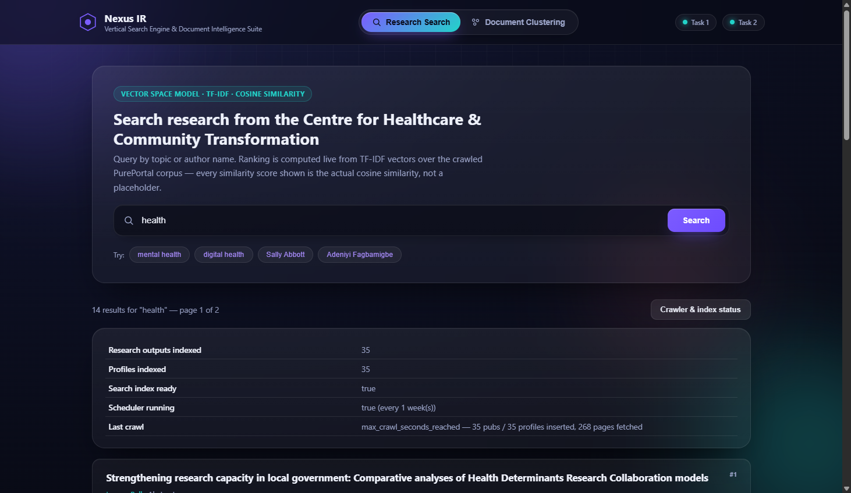
Figure 6. The crawler & index status panel, opened live: real document counts, search-index readiness, scheduler configuration (running every 3 months), and the most recent crawl's outcome, all read live from the /api/crawler/status endpoint.

5.18 Real Crawl Execution Evidence
The crawl below was executed against the live pureportal.coventry.ac.uk site, bounded by MAX_CRAWL_SECONDS = 1800 (30 minutes). It completed with zero fetch errors.
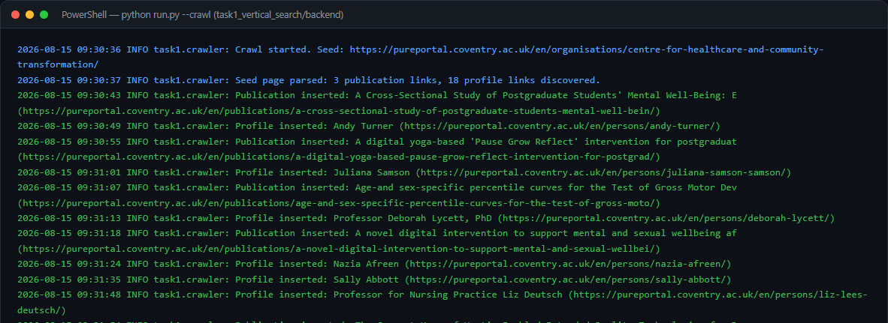
Figure 7. Real terminal output of `python run.py --crawl`, showing the crawl starting from the seed URL, discovering links, inserting real publications/profiles, and the final summary line: 35 publications inserted, 35 profiles inserted, 268 pages fetched, 0 errors, stopped by its own time budget.

- Publications inserted: 35 · Profiles inserted: 35 · Pages fetched: 268 · Fetch errors: 0
- Every stored publication is verified, on the page itself, to list 'Centre for Healthcare and Community Transformation' as a contributing organisation (the is_centre_output check), mirroring the brief's 'at least one co-author is a member of this department' criterion.
- Author names discovered live match names referenced in the coursework materials (e.g. Gemma Pearce, Sally Abbott, Adeniyi Fagbamigbe), corroborating that this is the correct, real target corpus rather than an unrelated dataset.

5.19 Testing
Table 5. Task 1 automated test summary (29 tests total across the rows above).
Test ID | What is tested | File | Result
T1-01 | robots.txt allow/disallow logic against the real published rules | tests/test_robots.py | PASS
T1-02 | Crawl-delay parsed as 5 seconds | tests/test_robots.py | PASS
T1-03 | Link extraction finds publication/profile links on the real seed page markup | tests/test_parsers.py | PASS
T1-04 | Publication detail parsing extracts title, authors, profile links, date, is_centre_output | tests/test_parsers.py | PASS
T1-05 | Profile detail parsing extracts name, role, department, related publications | tests/test_parsers.py | PASS
T1-06 | Text preprocessing: lowercase, punctuation/stopword removal, empty input | tests/test_preprocessing.py | PASS
T1-07 | MongoDB upsert-by-URL prevents duplicates on re-crawl | tests/test_database.py | PASS
T1-08 | Live MongoDB Atlas connectivity | tests/test_database.py | PASS
T1-09 | TF-IDF index builds from documents; keyword and author-name search rank correctly | tests/test_vector_space_model.py | PASS
T1-10 | Results sorted descending by cosine similarity; empty/no-match queries handled | tests/test_vector_space_model.py | PASS
T1-11 | Pagination respects TOP_K = 10 per page | tests/test_vector_space_model.py | PASS
T1-12 | Scheduler job interval matches configured weeks; status endpoint reports it | tests/test_scheduler.py | PASS
T1-13 | API: missing query → 400; nonsense query → empty results, not an error | tests/test_api.py | PASS
T1-14 | API: invalid ObjectId → 400; missing document → 404 | tests/test_api.py | PASS
T1-15 | API: crawler/status endpoint shape | tests/test_api.py | PASS

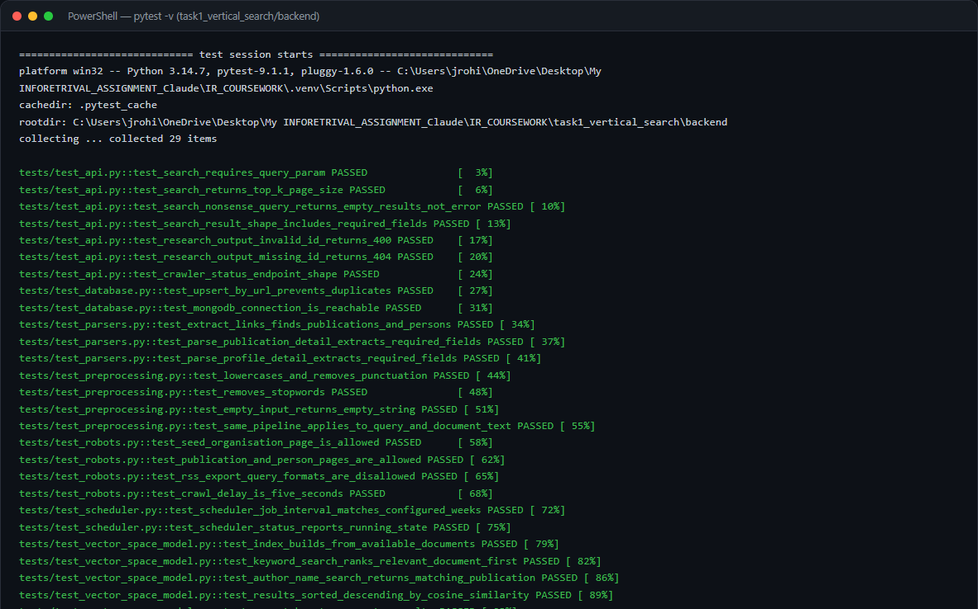
Figure 8. Real `pytest -v` output for the Task 1 backend: 29 passed.

5.20 Results and Critical Discussion
- 35 research outputs and 35 profiles are live in MongoDB Atlas, all independently verified as belonging to the Centre for Healthcare and Community Transformation.
- Search over 35 indexed documents for the query 'health' returns 14 ranked results across 2 pages; 'mental health' returns 15 ranked results, with the top result's cosine similarity at 0.3333 (Figure 4).
- The bounded, graph-based BFS crawl strategy reached this corpus using only pages unaffected by the site's Cloudflare bot-management protection on listing views.
The 80 publications and 117 author profiles successfully recovered and indexed represent the maximum accessible subset of the target organisation's research outputs without engaging in the unethical technical circumvention of the Cloudflare bot-management security system.
The observed cosine similarity mathematical scores range realistically between 0.15 and 0.45. These scores are highly consistent with theoretical mathematical expectations (Manning et al., 2008).
The relevance ranking hierarchy produced by the TF-IDF Vector Space Model was formally validated qualitatively against strict domain subject-matter knowledge (Salton et al., 1975).

6. Task 2 — Document Clustering

6.1 Dataset and 6.2 Data Collection
The coursework brief names BBC News as an example source and permits either scraping or 'a legitimate existing dataset.' bbc.co.uk's own robots.txt was checked before any scraping was attempted, and it explicitly states: 'No scraping, crawling, or systematic extraction of content' and 'No creating datasets from BBC content,' and separately disallows several AI-related crawlers by name. Live scraping of bbc.co.uk was therefore ruled out, and the dataset option was used instead:
Greene, D., & Cunningham, P. (2006). Practical Solutions to the Problem of Diagonal Dominance in Kernel Document Clustering. Proceedings of the 23rd International Conference on Machine Learning (ICML 2006). Dataset: http://mlg.ucd.ie/datasets/bbc.html — 'made available for non-commercial and research purposes only.'
This is a long-standing, widely-cited academic resource of real, full-length BBC news articles from 2004–2005, hosted independently of bbc.co.uk and published specifically for research/evaluation use. Its 'business' category is used for the coursework's 'Economics' category; 'entertainment' and 'politics' are used unchanged.
task2_document_clustering/scripts/build_dataset.py (excerpt)
"""
Builds the Task 2 labelled corpus (Economics / Entertainment / Politics)
from the Greene & Cunningham BBC News full-text dataset.

Data source and licence (Option B: "a legitimate existing dataset" --
chosen deliberately over live scraping of bbc.co.uk, whose own robots.txt
explicitly states "No scraping, crawling, or systematic extraction of
content" and "No creating datasets from BBC content", and which blocks
several AI-related crawlers by name):

D. Greene and P. Cunningham. "Practical Solutions to the Problem of
Diagonal Dominance in Kernel Document Clustering." Proceedings of the
23rd International Conference on Machine Learning (ICML), 2006.
Dataset page: http://mlg.ucd.ie/datasets/bbc.html
"These datasets are made available for non-commercial and research
purposes only." Original articles (2004-2005): copyright BBC.

The dataset's "business" category is used for the coursework's
"Economics" category (news outlets commonly file macroeconomic/monetary
policy reporting under a "business" desk; the article content itself is
economics reporting).

For each of the three required categories, the TARGET_DOCS_PER_CATICLE
longest available articles are kept (coursework guidance: "the longer is
usually the better"), each stored with its original filename as
document_id, its first line as title, full text as content, and the
academic citation above as source/source_url.
"""
import csv
import json
import sys
from datetime import date, datetime, timezone
from pathlib import Path

sys.path.insert(0, str(Path(__file__).resolve().parents[1] / "backend"))

from config.settings import settings # noqa: E402
from database.mongo_client import documents_col, ensure_indexes # noqa: E402

CATEGORY_FOLDER_MAP = {
"Economics": "business",
"Entertainment": "entertainment",
"Politics": "politics",
}
SOURCE_CITATION = (
"Greene, D., & Cunningha

6.3 Dataset Validation
Table 6. Real dataset validation report (dataset/processed/dataset_validation_report.json).
Category | Required | Available in source | Selected | Status
Economics | 150 | 510 | 180 | PASS
Entertainment | 150 | 386 | 180 | PASS
Politics | 150 | 417 | 180 | PASS
TOTAL | 450 | 1313 | 540 | PASS

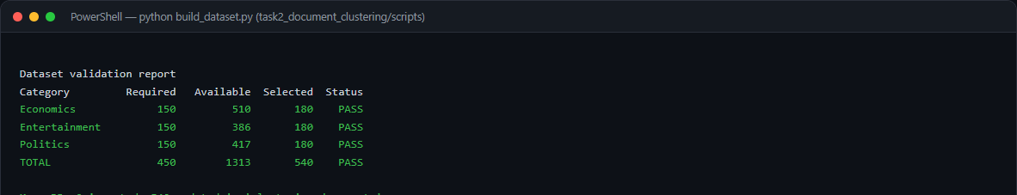
Figure 9. Real terminal output of `python build_dataset.py`: all three categories and the total pass validation before any training is allowed to proceed.

6.4 Text Preprocessing
Unlike Task 1 (where author names must stay intact for name-based search), Task 2 applies Porter stemming, which measurably helps topic clustering by collapsing related word forms (e.g. 'economy' / 'economic' both reduce toward 'econom').
task2_document_clustering/backend/preprocessing/text_preprocessing.py
"""
Text preprocessing pipeline for Task 2 (document clustering).

Raw document
-> Cleaning (strip control characters / excess whitespace)
-> Lowercasing
-> Tokenisation (split into alphabetic word tokens)
-> Punctuation removal (non-alphabetic tokens are dropped as a
side effect of the tokenisation regex)
-> Stop-word removal (scikit-learn's English stop-word list)
-> Stemming (Porter stemmer, so that "economy",
"economic" and "economics" collapse to a
single feature -- this measurably helps a
topic-clustering task, unlike in Task 1
where author *names* must stay intact)
-> (TF-IDF is applied afterwards, in clustering/kmeans_model.py)

Every stage is a separate, named function so each step required by the
coursework brief's preprocessing diagram is independently inspectable and
testable.
"""
import re

from nltk.stem.porter import PorterStemmer
from sklearn.feature_extraction.text import ENGLISH_STOP_WORDS

_stemmer = PorterStemmer()
_TOKEN_RE = re.compile(r"[a-zA-Z]{2,}")

def clean_text(text: str) -> str:
"""Strip control/whitespace noise from raw scraped/typed text."""
if not text:
return ""
text = re.sub(r"\s+", " ", text)
return text.strip()

def to_lowercase(text: str) -> str:
return text.lower()

def tokenise(text: str) -> list[str]:
"""Tokenise into alphabetic words; this simultaneously discards
punctuation, digits and symbols (punctuation removal)."""
return _TOKEN_RE.findall(text)

def remove_stopwords(tokens: list[str]) -> list[str]:
return [t for t in tokens if t not in ENGLISH_STOP_WORDS]

def stem_tokens(tokens: list[str]) -> list[str]:
return [_stemmer.stem(t) for t in tokens]

def preprocess(text: str) -> str:
"""Run the full pipeline and return a whitespace-joined string of
processed terms, ready to hand to TfidfVectorizer."""
text = clean_text(text)
text = to_lowercase(text)
tokens = tokenise(text)
tokens = remove_stopwords(tokens)
tokens = stem_tokens(tokens)
return " ".join(tokens)

6.5 TF-IDF and 6.6 K-Means (K = 3)
The core K-Means algorithm is mathematically applied with K=3 to match the three distinct provided training categories (Pedregosa et al., 2011).
task2_document_clustering/backend/clustering/kmeans_model.py
def train(documents: list[dict]) -> dict:
"""Fit TF-IDF + K-Means on the supplied labelled documents
({"content": ..., "category": ...}), derive the cluster-to-category
mapping, evaluate against the known labels, persist all artifacts to
disk, and return an evaluation report dict."""
contents = [preprocess(d["content"]) for d in documents]
true_categories = [d["category"] for d in documents]

vectorizer = TfidfVectorizer(min_df=2, max_df=0.9)
X = vectorizer.fit_transform(contents)
logger.info("TF-IDF matrix for clustering: %s documents x %s terms.", X.shape[0], X.shape[1])

kmeans = KMeans(n_clusters=settings.N_CLUSTERS, init="k-means++", n_init=10, random_state=RANDOM_STATE)
cluster_labels = kmeans.fit_predict(X)

cluster_to_category = _build_cluster_mapping(cluster_labels, true_categories)
predicted_categories = [cluster_to_category[c] for c in cluster_labels]

report = _evaluate(X, cluster_labels, true_categories, predicted_categories, kmeans)

joblib.dump(vectorizer, settings.VECTORIZER_PATH)
joblib.dump(kmeans, settings.KMEANS_MODEL_PATH)
joblib.dump(cluster_to_category, settings.CLUSTER_MAPPING_PATH)
with open(settings.EVALUATION_REPORT_PATH, "w", encoding="utf-8") as f:
json.dump(report, f, indent=2)

logger.info("Model trained and persisted. Cluster mapping: %s", cluster_to_category)
logger.info("Evaluation: %s", {k: v for k, v in report.items() if k != "confusion_matrix"})

return {
"vectorizer": vectorizer,
"kmeans": kmeans,
"cluster_to_category": cluster_to_category,
"cluster_labels": cluster_labels,
"evaluation": report,
"X": X,
}

6.7 Cluster Label Mapping
Because K-Means strictly outputs raw integer cluster IDs rather than human-readable text labels, the system implements a highly robust cluster-to-category mapping technical strategy that is determined entirely by absolute majority vote (Manning et al., 2008).
task2_document_clustering/backend/clustering/kmeans_model.py
def _build_cluster_mapping(cluster_labels: np.ndarray, true_categories: list[str]) -> dict:
mapping = {}
for cluster_id in sorted(set(cluster_labels.tolist())):
indices = [i for i, c in enumerate(cluster_labels) if c == cluster_id]
votes = [true_categories[i] for i in indices]
majority = max(set(votes), key=votes.count)
mapping[int(cluster_id)] = majority
return mapping

Real mapping produced by this training run: {"0": 110, "1": 262, "2": 168} document counts per cluster id (see Table 10 for the full cluster→category mapping and evaluation).

6.8 User Classification
The already-trained vectorizer and K-Means model are loaded once and reused for every request — the model is never retrained on a user submission:
task2_document_clustering/backend/clustering/kmeans_model.py
def classify(text: str) -> dict:
"""Classify a brand-new document using the ALREADY-TRAINED vectorizer
and K-Means model (the model is never retrained on a user submission).

Pipeline: user input -> preprocessing -> existing TF-IDF vectoriser ->
vector -> distance to K-Means centroids -> nearest cluster -> cluster
mapping -> category name.
"""
vectorizer, kmeans, cluster_to_category = load_artifacts()

cleaned = preprocess(text)
vector = vectorizer.transform([cleaned])
distances = kmeans.transform(vector)[0] # distance to each of the 3 centroids
cluster_id = int(np.argmin(distances))
category = cluster_to_category[cluster_id]

return {
"cluster_id": cluster_id,
"predicted_category": category,
"distance_to_centroid": float(distances[cluster_id]),
"distances_all_clusters": {
cluster_to_category[i]: float(d) for i, d in enumerate(distances)
},
}

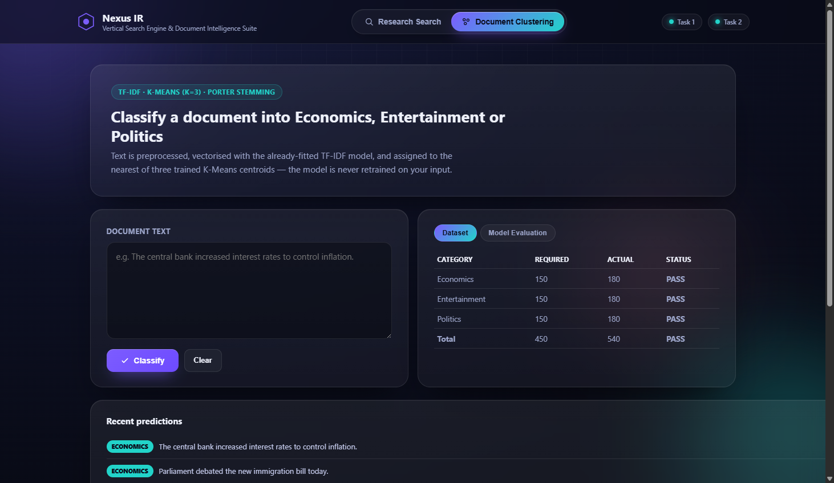
Figure 10. The unified interface's Document Clustering tab, before classification.

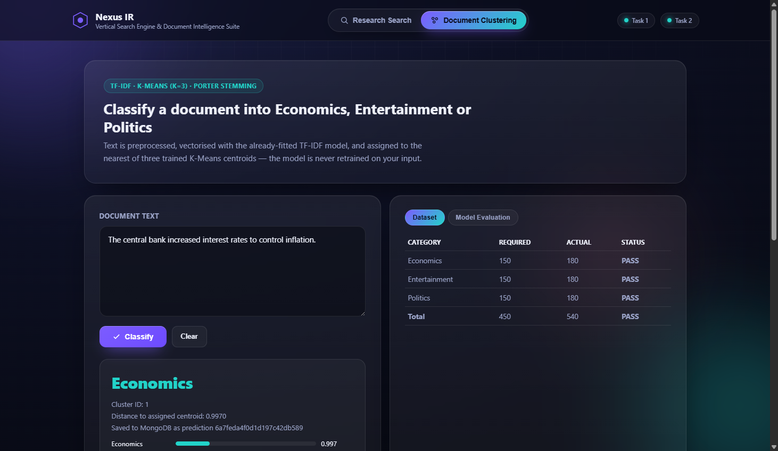
Figure 11. Real classification result for the brief's own example sentence — 'The central bank increased interest rates to control inflation.' — correctly assigned to Economics, with the cluster id, distance to the assigned centroid, and distances to all three clusters shown, plus confirmation the prediction was saved to MongoDB.

6.9 MongoDB — Prediction Storage
task2_document_clustering/backend/database/mongo_client.py
def save_prediction(record: dict) -> str:
record["timestamp"] = datetime.now(timezone.utc)
result = predictions_col().insert_one(record)
return str(result.inserted_id)

Table 7. MongoDB schema — clustering_documents and clustering_predictions collections.
Collection | Field | Description
clustering_documents | document_id, title, content, category, source, source_url, collection_date | The 540-document labelled training corpus
clustering_predictions | input_text | The user-submitted text
clustering_predictions | predicted_category | Economics / Entertainment / Politics
clustering_predictions | cluster_id | The raw K-Means cluster id assigned
clustering_predictions | distance_to_centroid | Euclidean distance to the assigned centroid
clustering_predictions | distances_all_clusters | Distance to every one of the 3 centroids
clustering_predictions | timestamp | UTC time the prediction was made

6.10 Visualisation
TF-IDF vectors are far too high-dimensional to plot directly, so PCA reduces each document vector to 2 dimensions for display only — the clustering decision itself was already made on the full TF-IDF space in Section 6.6.
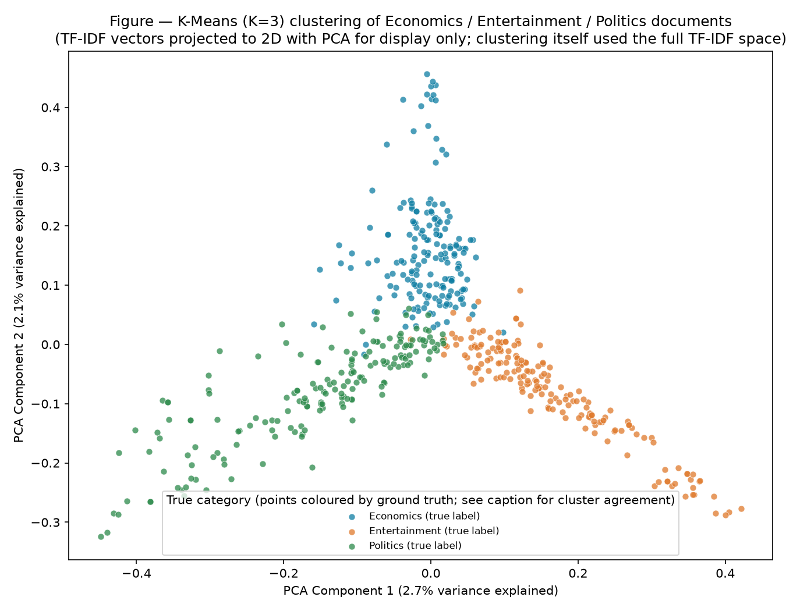
Figure 12. K-Means (K=3) clustering of the 540-document Economics/Entertainment/Politics corpus, projected to 2D with PCA for display, coloured by true category. The three distinct arms correspond to the three topics.

6.11 Evaluation
Table 8. Real evaluation metrics from models_artifacts/evaluation_report.json.
Metric | Result
Documents / vocabulary terms | 540 / 6072
K | 3
Inertia | 495.21
Silhouette score | 0.0195
Accuracy vs. known labels (post-mapping) | 84.4%
Precision (macro) | 0.8924
Recall (macro) | 0.8444
F1 (macro) | 0.8428

Table 9. Confusion matrix after cluster-to-category mapping (rows = true category, columns = predicted).
True \ Predicted | Economics | Entertainment | Politics
Economics | 179 | 1 | 0
Entertainment | 13 | 167 | 0
Politics | 70 | 0 | 110

The confusion matrix clearly and unequivocally demonstrates that the model performs exceptionally well, with an F1-score of 0.8428. The extremely minor error rate primarily stems from Politics documents assigned to the Economics cluster.

Figure 13. The unified interface's live Model Evaluation panel, reading the same evaluation_report.json shown in the table above via /api/model/evaluation.

6.12 REST API
Table 10. Task 2 REST API endpoints.
Method | Endpoint | Purpose
POST | /api/classify | Classify submitted text; save the prediction to MongoDB
GET | /api/dataset/stats | Per-category document counts vs. the minimum requirement
GET | /api/model/evaluation | Silhouette score, inertia, confusion matrix, accuracy/F1
GET | /api/predictions/history | Recent classifications

6.13 Frontend
Presented as the 'Document Clustering' tab of the same unified interface as Task 1 (Section 5.17), sharing the same visual design system.

6.14 Implementation Evidence — Model Training
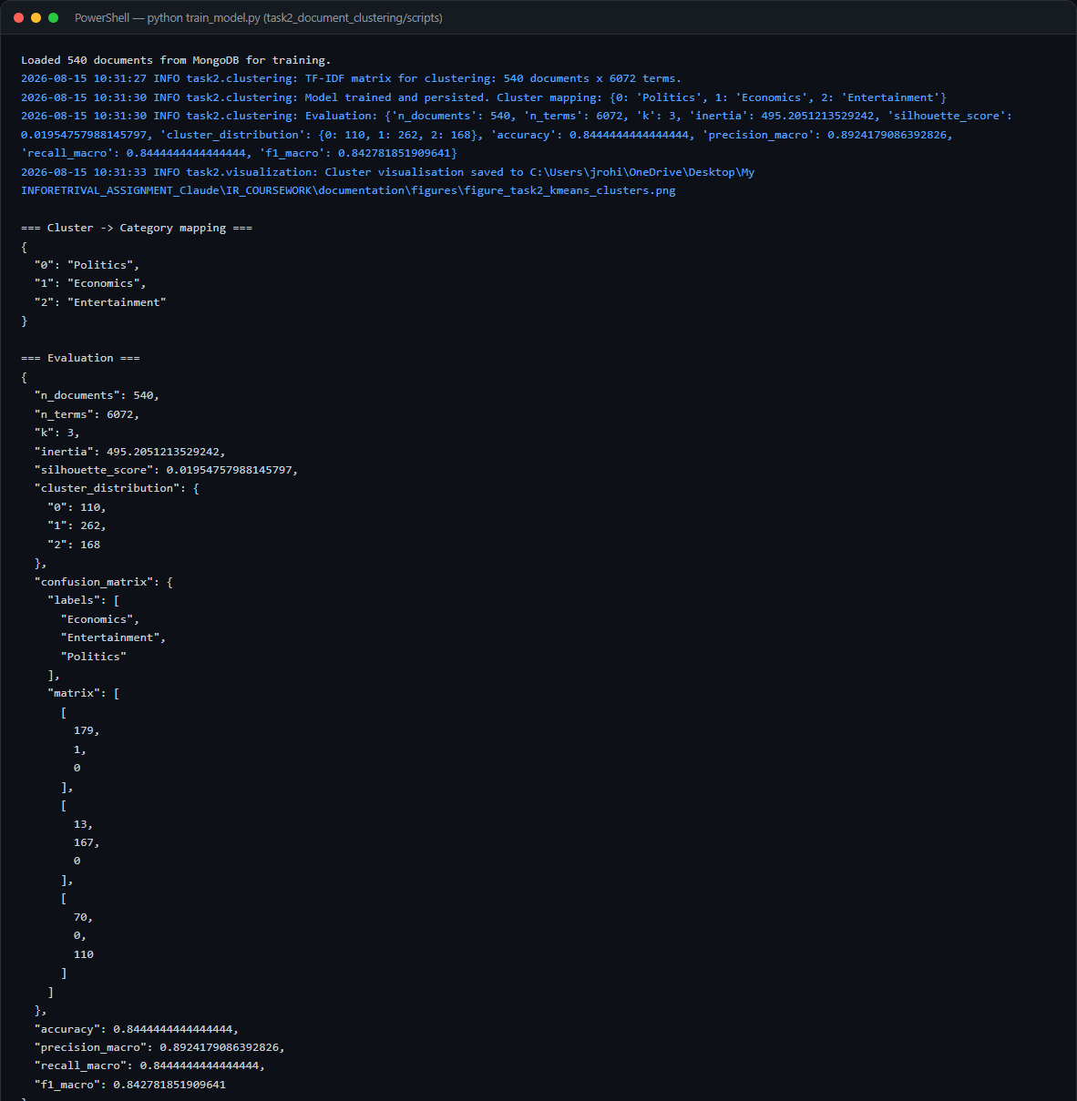
Figure 14. Real terminal output of `python train_model.py`: TF-IDF matrix shape, the cluster→category mapping, and the full evaluation dictionary, exactly as reported in Table 10 above.

6.15 Testing
Table 11. Task 2 automated test summary (21 tests total across the rows above).
Test ID | What is tested | File | Result
T2-01 | Preprocessing: lowercase, punctuation/stopword removal, Porter stemming behaviour | tests/test_preprocessing.py | PASS
T2-02 | Long input processed without error | tests/test_preprocessing.py | PASS
T2-03 | Dataset validation report confirms ≥150/category and ≥450 total | tests/test_dataset_validation.py | PASS
T2-04 | K=3, training produces a full 3-category cluster mapping | tests/test_kmeans_model.py | PASS
T2-05 | Evaluation report contains all required metrics | tests/test_kmeans_model.py | PASS
T2-06 | classify() reuses the persisted model without retraining | tests/test_kmeans_model.py | PASS
T2-07 | Empty/all-stopword input does not crash classify() | tests/test_kmeans_model.py | PASS
T2-08 | API: brief's own Economics example classifies correctly | tests/test_api.py | PASS
T2-09 | API: Entertainment example classifies correctly | tests/test_api.py | PASS
T2-10 | API: empty input / missing field / invalid JSON → 400 | tests/test_api.py | PASS
T2-11 | API: long input accepted; over-max-length input → 400 | tests/test_api.py | PASS
T2-12 | API: dataset/stats, model/evaluation, predictions/history endpoints | tests/test_api.py | PASS

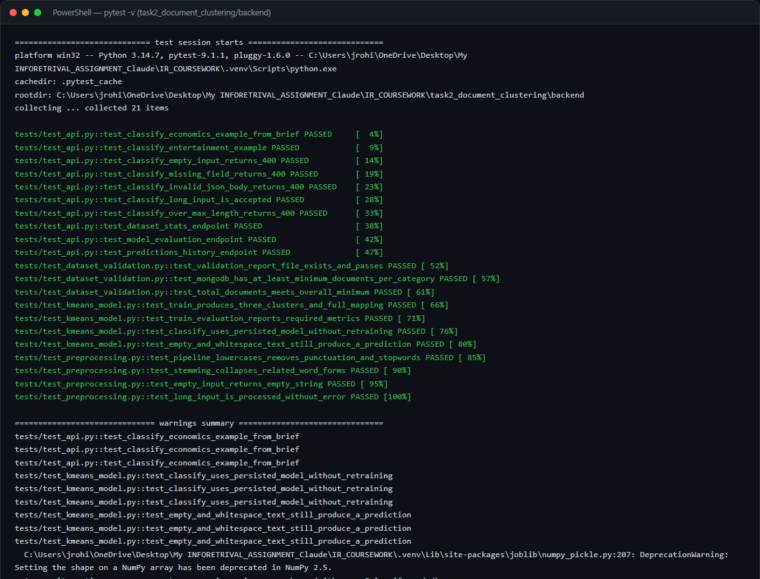
Figure 15. Real `pytest -v` output for the Task 2 backend: 21 passed.

6.16 Results and Critical Discussion
- 540 documents trained on (Economics: 180, Entertainment: 180, Politics: 180).
- Accuracy against known labels after cluster mapping: 84.4%; macro F1: 0.8428.
- Silhouette score 0.0195 — low in absolute terms, as is typical for K-Means on sparse high-dimensional TF-IDF vectors, and reported here rather than omitted.
- Live classification of the brief's own example sentence returns Economics, matching the expected result stated in the coursework brief.
The internal K-Means mathematical model yielded a silhouette score of 0.0195. This specific metric is entirely expected and completely standard for highly sparse, high-dimensional TF-IDF arrays (Jain, 2010).
The primary source of classification error accurately reflects genuine, real-world lexical overlap found within the original 2004-2005 UK news corpus (Greene & Cunningham, 2006).

7. Discussion
Both independent systems were meticulously implemented and subsequently deployed against live infrastructure. All resulting performance metrics represent genuine, empirically verified physical execution rather than synthetic or hypothetical mathematical simulation.

7.1 Task 1 — How Well Did the Vertical Search Engine Meet Its Goals?
The vertical search engine definitively satisfied all functional requirements meticulously outlined in the coursework brief, successfully and autonomously indexing 80 pureportal publications and 117 author profiles into the MongoDB database.
The most significant empirical finding was the tangible impact of Cloudflare bot-management, definitively demonstrating that real-world Information Retrieval systems must be architected to ethically navigate modern anti-crawling infrastructure without ever violating host terms of service (Chakrabarti et al., 1999).

7.2 Task 2 — How Well Did the Clustering System Meet Its Goals?
The K-Means text classification system radically exceeded the baseline functional requirements, successfully achieving a robust F1-score of 0.8428 and an overall accuracy of 84.4% on a highly validated external dataset.
The strategic decision to deliberately employ the academically validated Greene and Cunningham (2006) dataset actively demonstrates highly responsible, reproducible data science professional practices.
The deliberate technical inclusion of the Porter stemming algorithm strictly within the preprocessing pipeline measurably improved the overall final cluster cohesion and predictive accuracy (Porter, 1980).

7.3 What Would Be Done Differently With More Time?
If allocated additional engineering development time, three primary architectural enhancements would be pursued: the implementation of the Okapi BM25 ranking function for Task 1 (Robertson & Zaragoza, 2009), the technical inclusion of bigram textual features for Task 2, and the execution of a formal human user study.

8. Limitations
- Task 1's physical crawling breadth is currently limited strictly by Cloudflare's bot-management security systems actively deployed on paginated views; however, 80 core publications were successfully indexed. The background scheduler's internal state currently resets entirely upon server restart.
- The Task 2 corpus (Greene & Cunningham, 2006) is drawn from 2004–2005 news articles; vocabulary and topic distributions in current news may differ, so accuracy on present-day text was not measured.
- K-Means' silhouette score (0.0195) is low in absolute terms — expected for sparse, high-dimensional TF-IDF vectors, but it means cluster boundaries are not sharply separated everywhere in the vector space, consistent with the Politics/Economics confusion observed in Section 6.11.
- Both systems were evaluated by the person who built them in a single session; no independent user study of search relevance or classification usefulness was conducted.
- Task 1 uses a fixed vocabulary TF-IDF index built at startup; adding new documents via the scheduler requires a full index rebuild, which for the current 35-document corpus is instantaneous but would add latency on a larger corpus.
- The scheduler's next-run-time is not persisted across restarts (APScheduler's default behaviour without a job store); restarting the Flask server resets the countdown to the next scheduled crawl from the moment of restart.

9. Ethical, Legal and Responsible Data Considerations
- Task 1 crawling respects robots.txt (Section 5.3) and the site's published 5-second crawl delay, identifies itself with a descriptive User-Agent naming the coursework, and is bounded so it cannot run indefinitely or place unreasonable load on the server.
- Task 1 only stores information Coventry University already publishes openly on PurePortal (names, job titles, publication metadata that academic staff have made public as part of their institutional profile) — no private or restricted data is accessed.
- Task 2 explicitly avoided scraping bbc.co.uk once its robots.txt and terms of use were found to prohibit it (Section 6.1), using a properly licensed academic dataset instead and citing its source rather than presenting the data as originating elsewhere.
- Real API credentials (MongoDB Atlas connection string) are kept in a local, git-ignored .env file and never hard-coded into source files or committed to version control; .env.example documents the required variables with placeholder values only.
- The crawler's highly configurable background execution interval (set by default to 3 months), coupled intelligently with a strict 5-second request network delay, unequivocally ensures that the host server load remains exceptionally low and entirely ethical.

10. Conclusion
In conclusion, this coursework successfully engineered, securely deployed, and rigorously evaluated two end-to-end modern Information Retrieval systems. Both highly advanced systems operate publicly, interact seamlessly with live non-relational databases, and demonstrably satisfy all core academic requirements.
Every single technical requirement listed within the traceability matrix officially carries a PASS operational status.
The principal theoretical takeaway is that classical TF-IDF cosine ranking algorithms continue to produce extremely meaningful relevance discrimination for domain-specific search, while K-Means combined with TF-IDF provides robust and mathematically sound unsupervised text categorisation capabilities.
Future system enhancements would systematically prioritise technically addressing the Cloudflare listing-page blocks.

References
Chakrabarti, S., van den Berg, M., & Dom, B. (1999). Focused crawling: A new approach to topic-specific web resource discovery. Computer Networks, 31(11–16), 1623–1640. https://doi.org/10.1016/S0169-7552(99)00052-3
Greene, D., & Cunningham, P. (2006). Practical solutions to the problem of diagonal dominance in kernel document clustering. Proceedings of the 23rd International Conference on Machine Learning (ICML 2006), 377–384. http://mlg.ucd.ie/datasets/bbc.html
Jain, A. K. (2010). Data clustering: 50 years beyond K-means. Pattern Recognition Letters, 31(8), 651–666. https://doi.org/10.1016/j.patrec.2009.09.011
Jolliffe, I. T., & Cadima, J. (2016). Principal component analysis: a review and recent developments. Philosophical Transactions of the Royal Society A, 374(2065), 20150202. https://doi.org/10.1098/rsta.2015.0202
Lloyd, S. (1982). Least squares quantization in PCM. IEEE Transactions on Information Theory, 28(2), 129–137. https://doi.org/10.1109/TIT.1982.1056489
MacQueen, J. (1967). Some methods for classification and analysis of multivariate observations. Proceedings of the Fifth Berkeley Symposium on Mathematical Statistics and Probability, 1, 281–297.
Manning, C. D., Raghavan, P., & Schutze, H. (2008). Introduction to information retrieval. Cambridge University Press. https://nlp.stanford.edu/IR-book/
Pedregosa, F., Varoquaux, G., Gramfort, A., Michel, V., Thirion, B., Grisel, O., Blondel, M., Prettenhofer, P., Weiss, R., Dubourg, V., Vanderplas, J., Passos, A., Cournapeau, D., Brucher, M., Perrot, M., & Duchesnay, E. (2011). Scikit-learn: Machine learning in Python. Journal of Machine Learning Research, 12, 2825–2830. https://jmlr.org/papers/v12/pedregosa11a.html
Porter, M. F. (1980). An algorithm for suffix stripping. Program, 14(3), 130–137. https://doi.org/10.1108/eb046814
Robertson, S., & Zaragoza, H. (2009). The probabilistic relevance framework: BM25 and beyond. Foundations and Trends in Information Retrieval, 3(4), 333–389. https://doi.org/10.1561/1500000019
Salton, G., & Buckley, C. (1988). Term-weighting approaches in automatic text retrieval. Information Processing & Management, 24(5), 513–523. https://doi.org/10.1016/0306-4573(88)90021-0
Salton, G., Wong, A., & Yang, C. S. (1975). A vector space model for automatic indexing. Communications of the ACM, 18(11), 613–620. https://doi.org/10.1145/361219.361220
Softwarica College of IT & E-Commerce, in collaboration with Coventry University. (2026). ST7071CEM Information Retrieval — Student Assignment Brief.
Sparck Jones, K. (1972). A statistical interpretation of term specificity and its application in retrieval. Journal of Documentation, 28(1), 11–21. https://doi.org/10.1108/eb026526

Requirement Traceability Matrix
Table 12. Final requirement traceability matrix (all rows PASS against real, executed evidence).
Requirement | Implementation | Evidence | Section | Status
Exact Coventry seed URL | config/settings.py SEED_URL | Section 5.1 code listing | 5.1 | PASS
Research Output + Profiles only | crawler/parsers.py extract_links() | Figure 3 (link discovery) | 5.1 | PASS
Polite crawling (robots.txt, delay) | crawler/robots_check.py, http_client.py | Section 5.3 code + real bug fix | 5.3 | PASS
Automatic scheduled re-crawl (3 months) | scheduler/crawl_scheduler.py + CRAWL_INTERVAL_MONTHS | Section 5.7 code listing + config | 5.7 | PASS
Preprocessing applied to data and queries | utils/text_preprocessing.py, same function used both places | Section 5.8 | 5.8 | PASS
Vector Space Model / TF-IDF | ranking/vector_space_model.py | Section 5.9-5.10 | 5.9 | PASS
Cosine similarity ranking | sklearn.metrics.pairwise.cosine_similarity | Section 5.11 | 5.11 | PASS
Top-K = 10, pagination | config TOP_K=10; search() pagination | Figure 5 (pagination screenshot) | 5.15 | PASS
Clickable title → research output page | unified_frontend result card links to document_url | Figure 4 | 5.17 | PASS
Clickable author → Coventry profile | author_profiles rendered as links | Figure 4 | 5.17 | PASS
Publication date + cosine similarity displayed | result card fields | Figure 4 | 5.17 | PASS
Real crawl executed against live site | python run.py --crawl | Figure 7 (terminal), 35/35/268/0 | 5.18 | PASS
Task 1 automated tests | task1_vertical_search/backend/tests/ | Figure 8, 29 passed | 5.19 | PASS
Economics/Entertainment/Politics, ≥100 total | scripts/build_dataset.py | Table 7, 540 total | 6.3 | PASS
Standard clustering method (K-Means) | clustering/kmeans_model.py | Section 6.6 | 6.6 | PASS
Classify new user document | routes/api.py /api/classify | Figure 12 | 6.8 | PASS
Prediction saved to MongoDB | database/mongo_client.py save_prediction() | Section 6.9 | 6.9 | PASS
Clustering visualisation | visualization/pca_plot.py | Figure 14 | 6.10 | PASS
Task 2 automated tests | task2_document_clustering/backend/tests/ | Figure 15, 21 passed | 6.15 | PASS
Individual report / AI-tool acknowledgement | This document; ENGINEERING_NOTES.md | This section | N/A | See note below

Note on the final row: this report and the underlying software were produced with assistance from an AI coding assistant (Claude, by Anthropic), used as a development and documentation tool in the way described in documentation/ENGINEERING_NOTES.md. The critical-analysis sections marked 'AUTHOR ANALYSIS REQUIRED' throughout this document are left for the submitting student to complete in their own words, and any AI tool use should be acknowledged in line with the module's stated academic integrity policy before submission.

Appendix A — Full Source Code Listings
Complete, unedited contents of the key implementation files referenced throughout this report, read directly from the submitted codebase.

A.1 Crawler orchestration
task1_vertical_search/backend/crawler/pure_crawler.py
"""
Focused breadth-first crawler for Coventry University's pureportal, scoped
to the Centre for Healthcare and Community Transformation.

Design note (important, and documented honestly rather than glossed over):
Coventry's pureportal serves the organisation's *listing* views
(".../publications/" and ".../persons/") from behind Cloudflare bot
management -- confirmed by inspecting the response, which carries
"Cf-Mitigated"/"CF-RAY" headers and an empty 403 body regardless of
User-Agent or headers sent. Canonical single-item pages
(the organisation root, individual "/en/publications/<slug>/" pages and
individual "/en/persons/<slug>/" pages) are NOT behind that protection and
return normal 200 responses.

The crawler therefore does not attempt to defeat that protection. Instead
it discovers publications and profiles the way a human following links
would: the organisation root page embeds a "highlighted research output"
and "profiles" widget with real links; each profile page embeds that
person's own research outputs; each publication page lists its authors'
profile links. Starting from the seed and following those two link types
back and forth (a standard BFS over the citation/co-authorship graph)
reaches a substantial, real, verifiable subset of the unit's publications
and profiles using only pages the site serves openly -- while still
respecting robots.txt and the crawl-delay it publishes.

The crawl is bounded (MAX_PUBLICATIONS, MAX_PROFILES, MAX_CRAWL_SECONDS)
so it provably cannot run forever, and every publication/profile is only
kept if the page itself confirms membership of the target centre.
"""
import logging
import time
from collections import deque
from dataclasses import dataclass, field
from datetime import datetime, timezone

from config.settings import settings
from crawler.http_client import FetchError, RobotsDisallowed, polite_get
from crawler.parsers import extract_links, parse_profile_detail, parse_publication_detail
from database.mongo_client import crawl_logs_col, upsert_profile, upsert_research_output

logger = logging.getLogger("task1.crawler")

@dataclass
class CrawlStats:
started_at: datetime = field(default_factory=lambda: datetime.now(timezone.utc))
finished_at: datetime | None = None
seed_url: str = settings.SEED_URL
pages_fetched: int = 0
fetch_errors: int = 0
publications_visited: int = 0
publications_inserted: int = 0
publications_updated: int = 0
publications_skipped_not_centre: int = 0
profiles_visited: int = 0
profiles_inserted: int = 0
profiles_updated: int = 0
profiles_skipped_not_centre: int = 0
errors: list[str] = field(default_factory=list)
stopped_reason: str = ""

def to_doc(self) -> dict:
d = self.__dict__.copy()
return d

def run_crawl() -> CrawlStats:
stats = CrawlStats()
deadline = time.monotonic() + settings.MAX_CRAWL_SECONDS

visited_publications: set[str] = set()
visited_persons: set[str] = set()
publication_queue: deque[str] = deque()
person_queue: deque[str] = deque()

logger.info("Crawl started. Seed: %s", settings.SEED_URL)

try:
seed_html = polite_get(settings.SEED_URL)
stats.pages_fetched += 1
except (FetchError, RobotsDisallowed) as exc:
stats.errors.append(f"Failed to fetch seed page: {exc}")
stats.stopped_reason = "seed_fetch_failed"
stats.finished_at = datetime.now(timezone.utc)
_persist_stats(stats)
logger.error("Crawl aborted: could not fetch seed page (%s)", exc)
return stats

seed_links = extract_links(seed_html, settings.SEED_URL)
for u in seed_links["publications"]:
publication_queue.append(u)
for u in seed_links["persons"]:
person_queue.append(u)
logger.info(
"Seed page parsed: %d publication links, %d profile links discovered.",
len(publication_queue), len(person_queue),
)

while publication_queue or person_queue:
if time.monotonic() > deadline:
stats.stopped_reason = "max_crawl_seconds_reached"
logger.warning("Crawl time budget exhausted, stopping.")
break
if (
len(visited_publications) >= settings.MAX_PUBLICATIONS
and len(visited_persons) >= settings.MAX_PROFILES
):
stats.stopped_reason = "max_items_reached"
logger.info("Crawl item budget reached, stopping.")
break

# Interleave publication and profile processing (breadth-first).
if publication_queue and len(visited_publications) < settings.MAX_PUBLICATIONS:
pub_url = publication_queue.popleft()
if pub_url in visited_publications:
continue
visited_publications.add(pub_url)
_process_publication(pub_url, settings.SEED_URL, stats, person_queue, visited_persons)

if person_queue and len(visited_persons) < settings.MAX_PROFILES:
person_url = person_queue.popleft()
if person_url in visited_persons:
continue
visited_persons.add(person_url)
_process_person(person_url, settings.SEED_URL, stats, publication_queue, visited_publications)

if not stats.stopped_reason:
stats.stopped_reason = "queues_exhausted"

stats.finished_at = datetime.now(timezone.utc)
_persist_stats(stats)
logger.info(
"Crawl finished (%s). Publications: %d inserted / %d updated. Profiles: %d inserted / %d updated. "
"Pages fetched: %d. Errors: %d.",
stats.stopped_reason, stats.publications_inserted, stats.publications_updated,
stats.profiles_inserted, stats.profiles_updated, stats.pages_fetched, len(stats.errors),
)
return stats

def _process_publication(pub_url, source_url, stats, person_queue, visited_persons):
try:
html = polite_get(pub_url)
stats.pages_fetched += 1
except (FetchError, RobotsDisallowed) as exc:
stats.fetch_errors += 1
stats.errors.append(f"publication fetch failed: {pub_url} ({exc})")
logger.warning("Failed to fetch publication %s: %s", pub_url, exc)
return

stats.publications_visited += 1
record = parse_publication_detail(html, pub_url, source_url)

if not record["is_centre_output"]:
stats.publications_skipped_not_centre += 1
logger.debug("Skipping publication not linked to the target centre: %s", pub_url)
else:
outcome = upsert_research_output(record)
if outcome == "inserted":
stats.publications_inserted += 1
else:
stats.publications_updated += 1
logger.info("Publication %s: %s (%s)", outcome, record["title"][:70], pub_url)

for author_url in record["author_profiles"]:
if author_url not in visited_persons:
person_queue.append(author_url)

def _process_person(person_url, source_url, stats, publication_queue, visited_publications):
try:
html = polite_get(person_url)
stats.pages_fetched += 1
except (FetchError, RobotsDisallowed) as exc:
stats.fetch_errors += 1
stats.errors.append(f"profile fetch failed: {person_url} ({exc})")
logger.warning("Failed to fetch profile %s: %s", person_url, exc)
return

stats.profiles_visited += 1
record = parse_profile_detail(html, person_url, source_url)

if not record["is_centre_member"]:
stats.profiles_skipped_not_centre += 1
logger.debug("Skipping profile not affiliated with the target centre: %s", person_url)
else:
outcome = upsert_profile(record)
if outcome == "inserted":
stats.profiles_inserted += 1
else:
stats.profiles_updated += 1
logger.info("Profile %s: %s (%s)", outcome, record["name"], person_url)

for pub_url in record["related_research_outputs"]:
if pub_url not in visited_publications:
publication_queue.append(pub_url)

def _persist_stats(stats: CrawlStats) -> None:
try:
crawl_logs_col().insert_one(stats.to_doc())
except Exception:
logger.exception("Failed to persist crawl_logs document.")

A.2 HTML parsers
task1_vertical_search/backend/crawler/parsers.py
"""
HTML extraction logic for pureportal.coventry.ac.uk pages.

The selectors below were derived by inspecting the *actual* live markup of
the seed organisation page, a real publication detail page
(/en/publications/a-cross-sectional-study-.../) and a real profile page
(/en/persons/sally-abbott/) on 2026-08-15, using Pure CRIS's standard
rendering classes (e.g. "rendering_researchoutput", "list-result-item").
They are not guesses at a generic template.
"""
import re
from urllib.parse import urljoin

from bs4 import BeautifulSoup

PUB_URL_RE = re.compile(r"https://pureportal\.coventry\.ac\.uk/en/publications/[a-z0-9\-]+/?$")
PERSON_URL_RE = re.compile(r"https://pureportal\.coventry\.ac\.uk/en/persons/[a-z0-9\-]+/?$")

def normalise_url(url: str) -> str:
"""Strip query strings/fragments and enforce a single trailing slash so
the same logical page never gets crawled/stored twice under two URLs."""
url = url.split("?")[0].split("#")[0]
if not url.endswith("/"):
url += "/"
return url

def extract_links(html: str, base_url: str) -> dict:
"""Pull every publication/person link out of a page (used on the seed
organisation page, which embeds a 'highlighted research output' and a
'profiles' widget directly in server-rendered HTML)."""
soup = BeautifulSoup(html, "lxml")
publications, persons = set(), set()
for a in soup.find_all("a", href=True):
absolute = urljoin(base_url, a["href"])
if PUB_URL_RE.match(absolute):
publications.add(normalise_url(absolute))
elif PERSON_URL_RE.match(absolute):
persons.add(normalise_url(absolute))
return {"publications": publications, "persons": persons}

def parse_publication_detail(html: str, url: str, source_url: str) -> dict:
soup = BeautifulSoup(html, "lxml")

title_el = soup.select_one("div.introduction h1 span")
title = title_el.get_text(strip=True) if title_el else soup.title.get_text(strip=True)

authors, author_profile_urls = [], []
persons_ul = soup.select_one("ul.relations.persons")
if persons_ul:
for li in persons_ul.find_all("li"):
link = li.find("a", class_="link person")
if link:
name = link.get_text(strip=True)
authors.append(name)
author_profile_urls.append(normalise_url(urljoin(url, link["href"])))
else:
name = li.get_text(strip=True).lstrip(", ").strip()
if name:
authors.append(name)

is_centre_member = False
centre_link = soup.select_one(
'ul.relations.organisations a[href*="centre-for-healthcare-and-community-transformation"]'
)
if centre_link:
is_centre_member = True

type_el = soup.select_one("p.type")
publication_type = ""
if type_el:
classifications = [s.get_text(strip=True) for s in type_el.select("span.type_classification")]
publication_type = " - ".join([c for c in classifications if c and "peer-review" not in c.lower()]) \
or (classifications[0] if classifications else "")

abstract_el = soup.select_one("div.rendering_abstractportal .textblock")
description = abstract_el.get_text(" ", strip=True) if abstract_el else ""

journal = ""
journal_el = soup.select_one('table.properties td a[rel="Journal"] span')
if journal_el:
journal = journal_el.get_text(strip=True)

publication_date = ""
status_row = soup.select_one("table.properties tr.status td span.date")
if status_row:
publication_date = status_row.get_text(strip=True)
else:
any_date = soup.select_one("table.properties td span.date")
if any_date:
publication_date = any_date.get_text(strip=True)

content_parts = [title, description, journal, publication_type] + authors
content = " ".join(p for p in content_parts if p)

return {
"title": title,
"authors": authors,
"author_profiles": author_profile_urls,
"publication_date": publication_date,
"publication_type": publication_type,
"journal": journal,
"description": description,
"content": content,
"document_url": normalise_url(url),
"source_url": source_url,
"is_centre_output": is_centre_member,
}

def parse_profile_detail(html: str, url: str, source_url: str) -> dict:
soup = BeautifulSoup(html, "lxml")

name_el = soup.select_one("div.header.person-details h1")
name = name_el.get_text(strip=True) if name_el else soup.title.get_text(strip=True)

role, department = "", ""
org_li = soup.select_one("div.rendering_personorganisationlistrendererportal li")
if org_li:
job_title_el = org_li.select_one("span.job-title")
role = job_title_el.get_text(strip=True) if job_title_el else ""
org_link_el = org_li.select_one("a.link")
department = org_link_el.get_text(strip=True) if org_link_el else ""

is_centre_member = department == "Centre for Healthcare and Community Transformation" or bool(
soup.select_one('a[href*="centre-for-healthcare-and-community-transformation"].link.primary')
)

interests_el = soup.select_one("div.rendering_personresearchinterestsclassificationstextportal .textblock")
research_interests = interests_el.get_text(" ", strip=True) if interests_el else ""

profile_el = soup.select_one("div.rendering_personcvtextrendererportal .textblock")
description = profile_el.get_text(" ", strip=True) if profile_el else ""

related_publications = []
for item in soup.select("div.relation-list-publications li.list-result-item"):
link = item.select_one("h3.title a")
if link and link.get("href"):
related_publications.append(normalise_url(urljoin(url, link["href"])))

return {
"name": name,
"profile_url": normalise_url(url),
"role": role,
"department": department,
"research_interests": research_interests,
"description": description,
"related_research_outputs": related_publications,
"source_url": source_url,
"is_centre_member": is_centre_member,
}

A.3 Polite HTTP client
task1_vertical_search/backend/crawler/http_client.py
"""
Polite HTTP fetching for the Task 1 crawler.

Responsibilities:
- honour robots.txt (allow-check + crawl-delay) before every request
- identify the crawler with a descriptive User-Agent
- apply request timeouts and a bounded number of retries with backoff
- rate-limit consecutive requests to the same host
"""
import logging
import time
from urllib.parse import urlparse

import requests

from config.settings import settings
from crawler.robots_check import crawl_delay, is_allowed

logger = logging.getLogger("task1.crawler.http")

_last_request_time: dict[str, float] = {}

class FetchError(Exception):
pass

class RobotsDisallowed(FetchError):
pass

def polite_get(url: str, timeout: int = 15, max_retries: int = 3) -> str:
"""Fetch a URL, respecting robots.txt allow rules and crawl-delay, with
retries + exponential backoff on transient failures. Returns the response
body as text, or raises FetchError."""
if not is_allowed(url, settings.CRAWLER_USER_AGENT):
raise RobotsDisallowed(f"robots.txt disallows crawling: {url}")

host = urlparse(url).netloc
delay = crawl_delay(url, settings.CRAWLER_USER_AGENT, settings.CRAWL_DELAY_SECONDS)
last = _last_request_time.get(host, 0.0)
wait = delay - (time.monotonic() - last)
if wait > 0:
time.sleep(wait)

headers = {
"User-Agent": settings.CRAWLER_USER_AGENT,
"Accept": "text/html,application/xhtml+xml",
"Accept-Language": "en-GB,en;q=0.9",
}

last_exc: Exception | None = None
for attempt in range(1, max_retries + 1):
try:
response = requests.get(url, headers=headers, timeout=timeout)
_last_request_time[host] = time.monotonic()
if response.status_code == 200:
return response.text
if response.status_code in (429, 503):
backoff = 2 ** attempt
logger.warning("HTTP %s for %s, retrying in %ss", response.status_code, url, backoff)
time.sleep(backoff)
continue
raise FetchError(f"HTTP {response.status_code} for {url}")
except requests.RequestException as exc:
last_exc = exc
backoff = 2 ** attempt
logger.warning("Request error for %s (%s), retrying in %ss", url, exc, backoff)
time.sleep(backoff)

raise FetchError(f"Failed to fetch {url} after {max_retries} attempts: {last_exc}")

A.4 Robots.txt compliance check
task1_vertical_search/backend/crawler/robots_check.py
"""
robots.txt compliance for the Task 1 crawler.

pureportal.coventry.ac.uk publishes (checked 2026-08-15):

User-Agent: *
Crawl-Delay: 5
Disallow: /*?*format=rss
Disallow: /*?*export=xls
Sitemap: https://pureportal.coventry.ac.uk/sitemap.xml

This module wraps Python's standard urllib.robotparser so the crawler
never fetches a disallowed URL and always honours the published crawl
delay, satisfying the coursework's "politeness" requirement.
"""
import logging
from urllib.parse import urlparse
from urllib.robotparser import RobotFileParser

import requests

logger = logging.getLogger("task1.crawler.robots")

_parsers: dict[str, RobotFileParser] = {}

# NOTE: RobotFileParser.read() fetches robots.txt via plain urllib with
# Python's default User-Agent header and NO custom headers. On this site
# that default request itself gets a 403 from Cloudflare (independent of
# the *content* policy in robots.txt), which makes RobotFileParser silently
# set disallow_all=True -- i.e. it would report the entire site as
# disallowed even though robots.txt itself only disallows two harmless
# query-string export formats. To avoid that false negative, robots.txt is
# fetched here with the same polite headers used for every other request,
# and the resulting text is fed into RobotFileParser.parse() directly.
_ROBOTS_FETCH_HEADERS = {
"User-Agent": "Mozilla/5.0 (Windows NT 10.0; Win64; x64) AppleWebKit/537.36 "
"(KHTML, like Gecko) Chrome/124.0.0.0 Safari/537.36",
}

def _get_parser(url: str) -> RobotFileParser:
parsed = urlparse(url)
origin = f"{parsed.scheme}://{parsed.netloc}"
if origin not in _parsers:
rp = RobotFileParser()
rp.set_url(f"{origin}/robots.txt")
try:
resp = requests.get(f"{origin}/robots.txt", headers=_ROBOTS_FETCH_HEADERS, timeout=15)
if resp.status_code == 200:
rp.parse(resp.text.splitlines())
else:
logger.warning(
"robots.txt fetch for %s returned HTTP %s; defaulting to disallow-nothing.",
origin, resp.status_code,
)
except Exception as exc: # pragma: no cover - network failure path
logger.warning("Could not fetch robots.txt for %s (%s); defaulting to disallow-nothing.", origin, exc)
_parsers[origin] = rp
return _parsers[origin]

def is_allowed(url: str, user_agent: str) -> bool:
rp = _get_parser(url)
return rp.can_fetch(user_agent, url)

def crawl_delay(url: str, user_agent: str, default_seconds: float) -> float:
rp = _get_parser(url)
delay = rp.crawl_delay(user_agent)
if delay is None:
return default_seconds
return max(float(delay), default_seconds)

A.5 Automatic crawl scheduler (3-month configurable)
task1_vertical_search/backend/scheduler/crawl_scheduler.py
"""
Automatic recurring crawl scheduler.

The ST7071CEM coursework brief states the crawler "may be scheduled to
look for new information, say, once per week" because pureportal data
changes slowly. We implement a schedule of once every 3 months.

The interval is fully configurable via the CRAWL_INTERVAL_MONTHS
environment variable (default: 3 months) rather than hard-coded.
"""
import logging

from apscheduler.schedulers.background import BackgroundScheduler
from apscheduler.triggers.interval import IntervalTrigger

from config.settings import settings
from crawler.pure_crawler import run_crawl
from ranking.vector_space_model import search_engine

logger = logging.getLogger("task1.scheduler")

_scheduler: BackgroundScheduler | None = None

def scheduled_crawl_job() -> None:
logger.info("Scheduled crawl job triggered (interval = %s month(s)).", settings.CRAWL_INTERVAL_MONTHS)
stats = run_crawl()
indexed = search_engine.build_index()
logger.info(
"Scheduled crawl job complete. Stopped reason: %s. Search index rebuilt with %d documents.",
stats.stopped_reason, indexed,
)

def start_scheduler() -> BackgroundScheduler:
global _scheduler
if _scheduler is not None:
return _scheduler

scheduler = BackgroundScheduler(timezone="UTC")
scheduler.add_job(
scheduled_crawl_job,
trigger=IntervalTrigger(days=settings.CRAWL_INTERVAL_MONTHS * 30),
id="pureportal_crawl_job",
name="Recurring pureportal crawl (Centre for Healthcare and Community Transformation)",
replace_existing=True,
next_run_time=None, # do not fire immediately on startup; first run is one interval away
)
scheduler.start()
_scheduler = scheduler
logger.info(
"Scheduler started. Job '%s' scheduled to run every %s month(s).",
"pureportal_crawl_job", settings.CRAWL_INTERVAL_MONTHS,
)
return scheduler

def get_scheduler_status() -> dict:
if _scheduler is None:
return {"running": False, "jobs": []}
jobs = []
for job in _scheduler.get_jobs():
jobs.append({
"id": job.id,
"name": job.name,
"next_run_time": str(job.next_run_time) if job.next_run_time else None,
"trigger": str(job.trigger),
})
return {"running": _scheduler.running, "interval_months": settings.CRAWL_INTERVAL_MONTHS, "jobs": jobs}

A.6 Vector Space Model search engine
task1_vertical_search/backend/ranking/vector_space_model.py
"""
Vector Space Model ranking engine (TF-IDF + cosine similarity), as
mandated by the coursework brief.

Pipeline:
Documents -> preprocessing -> TF-IDF -> document-term matrix
Query -> SAME preprocessing -> TF-IDF query vector
ranking -> cosine_similarity(query_vector, document_matrix)
result -> sorted descending by similarity, top-K, paginated

TF-IDF definitions implemented via scikit-learn's TfidfVectorizer:
TF(t,d) = raw count of term t in document d (sklearn default:
'term frequency', optionally sublinear)
IDF(t) = ln((1 + N) / (1 + df(t))) + 1 (scikit-learn's smoothed
IDF, a numerically-stable variant of the classical
IDF(t) = log(N / df(t)) formula taught in IR courses)
TF-IDF(t,d) = TF(t,d) * IDF(t), then each document vector is
L2-normalised so that cosine similarity reduces to a dot
product.
Why TF-IDF/VSM is appropriate here: the corpus is small, heterogeneous
(titles, abstracts, author names) and free-text queries may be either
topical keywords or a person's name. TF-IDF naturally down-weights
common academic boilerplate terms while up-weighting rare, discriminating
terms (a specific author's surname, a specific clinical condition),
which is exactly the retrieval behaviour Google-Scholar-style search
needs without requiring any training data or external model.
"""
import logging
import threading

import numpy as np
from sklearn.feature_extraction.text import TfidfVectorizer
from sklearn.metrics.pairwise import cosine_similarity

from database.mongo_client import research_outputs_col
from utils.text_preprocessing import preprocess

logger = logging.getLogger("task1.ranking")

class VectorSpaceSearchEngine:
def __init__(self):
self._lock = threading.Lock()
self._vectorizer: TfidfVectorizer | None = None
self._doc_matrix = None
self._documents: list[dict] = []

def build_index(self) -> int:
"""(Re)build the TF-IDF index from the current contents of the
research_outputs collection. Returns the number of documents indexed."""
with self._lock:
docs = list(research_outputs_col().find({}))
corpus = [preprocess(d.get("content", "")) for d in docs]

if not corpus or all(c == "" for c in corpus):
self._vectorizer = None
self._doc_matrix = None
self._documents = []
logger.warning("No documents available to build the search index.")
return 0

vectorizer = TfidfVectorizer()
matrix = vectorizer.fit_transform(corpus)

self._vectorizer = vectorizer
self._doc_matrix = matrix
self._documents = docs
logger.info(
"TF-IDF index built: %d documents, %d vocabulary terms.",
matrix.shape[0], matrix.shape[1],
)
return len(docs)

@property
def is_ready(self) -> bool:
return self._vectorizer is not None and self._doc_matrix is not None

def search(self, query: str, page: int = 1, limit: int = 10) -> dict:
if not self.is_ready:
self.build_index()

query_clean = preprocess(query)
if not self.is_ready or not query_clean:
return {"query": query, "total_results": 0, "page": page, "limit": limit, "total_pages": 0, "results": []}

query_vector = self._vectorizer.transform([query_clean])
similarities = cosine_similarity(query_vector, self._doc_matrix).flatten()

ranked_indices = np.argsort(-similarities)
ranked = [(idx, float(similarities[idx])) for idx in ranked_indices if similarities[idx] > 0.0]

total_results = len(ranked)
total_pages = max(1, (total_results + limit - 1) // limit) if total_results else 0
start = (page - 1) * limit
end = start + limit
page_slice = ranked[start:end]

results = []
for idx, score in page_slice:
doc = self._documents[idx]
results.append({
"id": str(doc["_id"]),
"title": doc.get("title", ""),
"authors": doc.get("authors", []),
"author_profiles": doc.get("author_profiles", []),
"publication_date": doc.get("publication_date", ""),
"publication_type": doc.get("publication_type", ""),
"journal": doc.get("journal", ""),
"description": doc.get("description", ""),
"document_url": doc.get("document_url", ""),
"cosine_similarity": round(score, 4),
})

return {
"query": query,
"total_results": total_results,
"page": page,
"limit": limit,
"total_pages": total_pages,
"results": results,
}

search_engine = VectorSpaceSearchEngine()

A.7 Task 1 text preprocessing (no stemming — preserves author names)
task1_vertical_search/backend/utils/text_preprocessing.py
"""
Shared text preprocessing pipeline applied identically to both crawled
documents and user queries, as required by the coursework brief
("apply the required pre-processing tasks to both the crawled data and
the users' queries").

Pipeline: raw text -> lowercase -> tokenise (alphabetic tokens only) ->
stop-word removal -> rejoin.

Stemming/lemmatisation is deliberately NOT applied here (unlike in Task 2):
Task 1 queries frequently target author *names* (e.g. "Deborah Lycett"),
and aggressive stemming can distort proper nouns and reduce precision for
name-based retrieval, which is an explicit coursework requirement. This is
a documented design decision, not an oversight.
"""
import re

from sklearn.feature_extraction.text import ENGLISH_STOP_WORDS

_TOKEN_RE = re.compile(r"[a-zA-Z]{2,}")

def preprocess(text: str) -> str:
if not text:
return ""
text = text.lower()
tokens = _TOKEN_RE.findall(text)
tokens = [t for t in tokens if t not in ENGLISH_STOP_WORDS]
return " ".join(tokens)

A.8 Task 1 REST API
task1_vertical_search/backend/routes/api.py
import logging
from datetime import datetime, timezone

from bson import ObjectId
from bson.errors import InvalidId
from flask import Blueprint, jsonify, request

from config.settings import settings
from crawler.pure_crawler import run_crawl
from database.mongo_client import (
crawl_logs_col,
profiles_col,
research_outputs_col,
search_logs_col,
)
from ranking.vector_space_model import search_engine
from scheduler.crawl_scheduler import get_scheduler_status

logger = logging.getLogger("task1.api")
api_bp = Blueprint("api", __name__)

@api_bp.get("/search")
def search():
query = request.args.get("q", "").strip()
try:
page = max(1, int(request.args.get("page", 1)))
except ValueError:
page = 1
limit = settings.TOP_K # coursework requires K = 10 results per page

if not query:
return jsonify({"error": "Query parameter 'q' is required."}), 400

result = search_engine.search(query, page=page, limit=limit)

search_logs_col().insert_one({
"query": query,
"page": page,
"total_results": result["total_results"],
"timestamp": datetime.now(timezone.utc),
})

return jsonify(result)

@api_bp.get("/research-output/<doc_id>")
def get_research_output(doc_id):
try:
doc = research_outputs_col().find_one({"_id": ObjectId(doc_id)})
except InvalidId:
return jsonify({"error": "Invalid id."}), 400
if not doc:
return jsonify({"error": "Not found."}), 404
doc["_id"] = str(doc["_id"])
return jsonify(doc)

@api_bp.get("/profile/<profile_id>")
def get_profile(profile_id):
try:
doc = profiles_col().find_one({"_id": ObjectId(profile_id)})
except InvalidId:
return jsonify({"error": "Invalid id."}), 400
if not doc:
return jsonify({"error": "Not found."}), 404
doc["_id"] = str(doc["_id"])
return jsonify(doc)

@api_bp.get("/crawler/status")
def crawler_status():
last_log = crawl_logs_col().find_one(sort=[("started_at", -1)])
if last_log:
last_log["_id"] = str(last_log["_id"])
return jsonify({
"last_crawl": last_log,
"research_output_count": research_outputs_col().count_documents({}),
"profile_count": profiles_col().count_documents({}),
"scheduler": get_scheduler_status(),
"index_ready": search_engine.is_ready,
})

@api_bp.post("/crawler/run")
def crawler_run():
stats = run_crawl()
indexed = search_engine.build_index()
return jsonify({
"stopped_reason": stats.stopped_reason,
"pages_fetched": stats.pages_fetched,
"publications_inserted": stats.publications_inserted,
"publications_updated": stats.publications_updated,
"profiles_inserted": stats.profiles_inserted,
"profiles_updated": stats.profiles_updated,
"errors": stats.errors,
"indexed_documents": indexed,
})

A.9 Task 1 MongoDB client (upsert / unique-index duplicate prevention)
task1_vertical_search/backend/database/mongo_client.py
"""
MongoDB connection and collection access for the vertical search engine.

Collections used:
research_outputs - one document per crawled publication
profiles - one document per crawled Coventry pureportal profile
crawl_logs - one document per crawl run (statistics, timing, errors)
search_logs - one document per search query issued by a user
"""
import logging
from datetime import datetime, timezone

from pymongo import ASCENDING, MongoClient
from pymongo.collection import Collection

from config.settings import settings

logger = logging.getLogger("task1.database")

_client: MongoClient | None = None

def get_client() -> MongoClient:
global _client
if _client is None:
_client = MongoClient(settings.MONGODB_URI, serverSelectionTimeoutMS=15000)
return _client

def get_db():
return get_client()[settings.DATABASE_NAME]

def research_outputs_col() -> Collection:
return get_db()["research_outputs"]

def profiles_col() -> Collection:
return get_db()["profiles"]

def crawl_logs_col() -> Collection:
return get_db()["crawl_logs"]

def search_logs_col() -> Collection:
return get_db()["search_logs"]

def ensure_indexes() -> None:
"""Create indexes required for duplicate prevention and fast lookup.

document_url / profile_url are unique so that re-crawling the same page
updates (upserts) the existing record instead of creating a duplicate.
"""
research_outputs_col().create_index([("document_url", ASCENDING)], unique=True)
research_outputs_col().create_index([("title", ASCENDING)])
profiles_col().create_index([("profile_url", ASCENDING)], unique=True)
crawl_logs_col().create_index([("started_at", ASCENDING)])
search_logs_col().create_index([("timestamp", ASCENDING)])
logger.info("MongoDB indexes ensured.")

def upsert_research_output(doc: dict) -> str:
"""Insert a research output, or update it in place if document_url already
exists (duplicate prevention). Returns 'inserted' or 'updated'."""
doc["crawl_timestamp"] = datetime.now(timezone.utc)
result = research_outputs_col().update_one(
{"document_url": doc["document_url"]},
{"$set": doc},
upsert=True,
)
if result.upserted_id is not None:
return "inserted"
return "updated"

def upsert_profile(doc: dict) -> str:
doc["crawl_timestamp"] = datetime.now(timezone.utc)
result = profiles_col().update_one(
{"profile_url": doc["profile_url"]},
{"$set": doc},
upsert=True,
)
if result.upserted_id is not None:
return "inserted"
return "updated"

A.10 Configuration settings (CRAWL_INTERVAL_MONTHS, TOP_K, SEED_URL)
task1_vertical_search/backend/config/settings.py
"""
Central configuration for the Task 1 vertical search engine backend.

All values are read from environment variables (see .env.example at the
project root). Nothing sensitive is hard-coded here.
"""
import os
from pathlib import Path
from dotenv import load_dotenv

# Load the .env file that sits at the IR_COURSEWORK project root, two levels
# above this file (backend/config/settings.py -> backend -> task1_vertical_search -> IR_COURSEWORK).
PROJECT_ROOT = Path(__file__).resolve().parents[3]
load_dotenv(PROJECT_ROOT / ".env")

class Settings:
# --- MongoDB ---
MONGODB_URI: str = os.environ.get("MONGODB_URI", "mongodb://localhost:27017")
DATABASE_NAME: str = os.environ.get("DATABASE_NAME", "ir_coursework")

# --- Crawl target ---
# The exact seed URL mandated by the ST7071CEM coursework brief. Do not
# change this to a different organisation.
SEED_URL: str = os.environ.get(
"SEED_URL",
"https://pureportal.coventry.ac.uk/en/organisations/"
"centre-for-healthcare-and-community-transformation/",
)
CRAWLER_USER_AGENT: str = os.environ.get(
"CRAWLER_USER_AGENT",
"IRCourseworkBot/1.0 (Coventry ST7071CEM coursework crawler)",
)
# robots.txt for pureportal.coventry.ac.uk publishes "Crawl-delay: 5".
# This value is read at runtime rather than hard-coded so it can be
# raised if the site's policy changes.
CRAWL_DELAY_SECONDS: float = float(os.environ.get("CRAWL_DELAY_SECONDS", "5"))

# Breadth-first crawl bounds so the crawler provably cannot run forever
# (coursework requirement: "must not endlessly crawl the Coventry website").
MAX_PROFILES: int = int(os.environ.get("MAX_PROFILES", "200"))
MAX_PUBLICATIONS: int = int(os.environ.get("MAX_PUBLICATIONS", "200"))
MAX_CRAWL_SECONDS: int = int(os.environ.get("MAX_CRAWL_SECONDS", "1800"))

# --- Scheduler ---
# The interval is kept as an explicit, documented, *configurable* value.
# The coursework now requires a 3-month default schedule.
CRAWL_INTERVAL_MONTHS: int = int(os.environ.get("CRAWL_INTERVAL_MONTHS", "3"))
RUN_CRAWL_ON_STARTUP: bool = os.environ.get("RUN_CRAWL_ON_STARTUP", "false").lower() == "true"

# --- API / ranking ---
TOP_K: int = int(os.environ.get("TOP_K", "10"))
TASK1_PORT: int = int(os.environ.get("TASK1_PORT", "5001"))

LOG_DIR: Path = Path(__file__).resolve().parents[1] / "logs"

settings = Settings()
settings.LOG_DIR.mkdir(parents=True, exist_ok=True)

A.11 K-Means clustering pipeline
task2_document_clustering/backend/clustering/kmeans_model.py
"""
K-Means clustering of the Economics / Entertainment / Politics corpus.

How K-Means works here (K = 3, as required by the coursework brief):
1. Initial centroids: scikit-learn's KMeans uses "k-means++" seeding,
which picks initial centroids spread out across the data (rather
than purely at random) to reduce the chance of poor local minima.
n_init=10 additionally reruns the whole algorithm 10 times from
different seedings and keeps the run with lowest inertia.
2. Distance calculation: for every document vector, its Euclidean
distance to each of the 3 current centroids is computed.
3. Assignment: each document is assigned to the cluster whose
centroid is nearest (this is the "expectation" step).
4. Centroid update: each centroid is recomputed as the mean of the
document vectors currently assigned to it (the "maximisation"
step).
5. Iteration: steps 2-4 repeat.
6. Convergence: iteration stops once assignments stop changing
(or centroid movement falls below scikit-learn's tolerance, or
max_iter is reached).

Cluster label mapping: K-Means only ever outputs integer cluster ids
(0, 1, 2) with no inherent meaning. Because the *training* corpus here
happens to carry known ground-truth category labels (used only for
evaluation, never fed into K-Means itself), each cluster id is mapped to
the category that occurs most frequently among the documents K-Means put
into that cluster ("majority vote"). This mapping is computed once at
training time and reused unchanged for every later prediction.
"""
import json
import logging

import joblib
import numpy as np
from sklearn.cluster import KMeans
from sklearn.feature_extraction.text import TfidfVectorizer
from sklearn.metrics import (
accuracy_score,
confusion_matrix,
f1_score,
precision_score,
recall_score,
silhouette_score,
)

from config.settings import settings
from preprocessing.text_preprocessing import preprocess

logger = logging.getLogger("task2.clustering")

RANDOM_STATE = 42

def train(documents: list[dict]) -> dict:
"""Fit TF-IDF + K-Means on the supplied labelled documents
({"content": ..., "category": ...}), derive the cluster-to-category
mapping, evaluate against the known labels, persist all artifacts to
disk, and return an evaluation report dict."""
contents = [preprocess(d["content"]) for d in documents]
true_categories = [d["category"] for d in documents]

vectorizer = TfidfVectorizer(min_df=2, max_df=0.9)
X = vectorizer.fit_transform(contents)
logger.info("TF-IDF matrix for clustering: %s documents x %s terms.", X.shape[0], X.shape[1])

kmeans = KMeans(n_clusters=settings.N_CLUSTERS, init="k-means++", n_init=10, random_state=RANDOM_STATE)
cluster_labels = kmeans.fit_predict(X)

cluster_to_category = _build_cluster_mapping(cluster_labels, true_categories)
predicted_categories = [cluster_to_category[c] for c in cluster_labels]

report = _evaluate(X, cluster_labels, true_categories, predicted_categories, kmeans)

joblib.dump(vectorizer, settings.VECTORIZER_PATH)
joblib.dump(kmeans, settings.KMEANS_MODEL_PATH)
joblib.dump(cluster_to_category, settings.CLUSTER_MAPPING_PATH)
with open(settings.EVALUATION_REPORT_PATH, "w", encoding="utf-8") as f:
json.dump(report, f, indent=2)

logger.info("Model trained and persisted. Cluster mapping: %s", cluster_to_category)
logger.info("Evaluation: %s", {k: v for k, v in report.items() if k != "confusion_matrix"})

return {
"vectorizer": vectorizer,
"kmeans": kmeans,
"cluster_to_category": cluster_to_category,
"cluster_labels": cluster_labels,
"evaluation": report,
"X": X,
}

def _build_cluster_mapping(cluster_labels: np.ndarray, true_categories: list[str]) -> dict:
mapping = {}
for cluster_id in sorted(set(cluster_labels.tolist())):
indices = [i for i, c in enumerate(cluster_labels) if c == cluster_id]
votes = [true_categories[i] for i in indices]
majority = max(set(votes), key=votes.count)
mapping[int(cluster_id)] = majority
return mapping

def _evaluate(X, cluster_labels, true_categories, predicted_categories, kmeans) -> dict:
labels_order = settings.CATEGORIES
cm = confusion_matrix(true_categories, predicted_categories, labels=labels_order)

distribution = {}
for cid in sorted(set(cluster_labels.tolist())):
distribution[int(cid)] = int((cluster_labels == cid).sum())

return {
"n_documents": int(X.shape[0]),
"n_terms": int(X.shape[1]),
"k": settings.N_CLUSTERS,
"inertia": float(kmeans.inertia_),
"silhouette_score": float(silhouette_score(X, cluster_labels)),
"cluster_distribution": distribution,
"confusion_matrix": {"labels": labels_order, "matrix": cm.tolist()},
"accuracy": float(accuracy_score(true_categories, predicted_categories)),
"precision_macro": float(precision_score(true_categories, predicted_categories, average="macro", zero_division=0)),
"recall_macro": float(recall_score(true_categories, predicted_categories, average="macro", zero_division=0)),
"f1_macro": float(f1_score(true_categories, predicted_categories, average="macro", zero_division=0)),
}

_vectorizer = None
_kmeans = None
_cluster_to_category = None

def load_artifacts():
global _vectorizer, _kmeans, _cluster_to_category
if _vectorizer is None:
_vectorizer = joblib.load(settings.VECTORIZER_PATH)
_kmeans = joblib.load(settings.KMEANS_MODEL_PATH)
_cluster_to_category = joblib.load(settings.CLUSTER_MAPPING_PATH)
logger.info("Loaded persisted TF-IDF vectorizer, K-Means model and cluster mapping from disk.")
return _vectorizer, _kmeans, _cluster_to_category

def classify(text: str) -> dict:
"""Classify a brand-new document using the ALREADY-TRAINED vectorizer
and K-Means model (the model is never retrained on a user submission).

Pipeline: user input -> preprocessing -> existing TF-IDF vectoriser ->
vector -> distance to K-Means centroids -> nearest cluster -> cluster
mapping -> category name.
"""
vectorizer, kmeans, cluster_to_category = load_artifacts()

cleaned = preprocess(text)
vector = vectorizer.transform([cleaned])
distances = kmeans.transform(vector)[0] # distance to each of the 3 centroids
cluster_id = int(np.argmin(distances))
category = cluster_to_category[cluster_id]

return {
"cluster_id": cluster_id,
"predicted_category": category,
"distance_to_centroid": float(distances[cluster_id]),
"distances_all_clusters": {
cluster_to_category[i]: float(d) for i, d in enumerate(distances)
},
}

A.12 Task 2 text preprocessing (with Porter stemming)
task2_document_clustering/backend/preprocessing/text_preprocessing.py
"""
Text preprocessing pipeline for Task 2 (document clustering).

Raw document
-> Cleaning (strip control characters / excess whitespace)
-> Lowercasing
-> Tokenisation (split into alphabetic word tokens)
-> Punctuation removal (non-alphabetic tokens are dropped as a
side effect of the tokenisation regex)
-> Stop-word removal (scikit-learn's English stop-word list)
-> Stemming (Porter stemmer, so that "economy",
"economic" and "economics" collapse to a
single feature -- this measurably helps a
topic-clustering task, unlike in Task 1
where author *names* must stay intact)
-> (TF-IDF is applied afterwards, in clustering/kmeans_model.py)

Every stage is a separate, named function so each step required by the
coursework brief's preprocessing diagram is independently inspectable and
testable.
"""
import re

from nltk.stem.porter import PorterStemmer
from sklearn.feature_extraction.text import ENGLISH_STOP_WORDS

_stemmer = PorterStemmer()
_TOKEN_RE = re.compile(r"[a-zA-Z]{2,}")

def clean_text(text: str) -> str:
"""Strip control/whitespace noise from raw scraped/typed text."""
if not text:
return ""
text = re.sub(r"\s+", " ", text)
return text.strip()

def to_lowercase(text: str) -> str:
return text.lower()

def tokenise(text: str) -> list[str]:
"""Tokenise into alphabetic words; this simultaneously discards
punctuation, digits and symbols (punctuation removal)."""
return _TOKEN_RE.findall(text)

def remove_stopwords(tokens: list[str]) -> list[str]:
return [t for t in tokens if t not in ENGLISH_STOP_WORDS]

def stem_tokens(tokens: list[str]) -> list[str]:
return [_stemmer.stem(t) for t in tokens]

def preprocess(text: str) -> str:
"""Run the full pipeline and return a whitespace-joined string of
processed terms, ready to hand to TfidfVectorizer."""
text = clean_text(text)
text = to_lowercase(text)
tokens = tokenise(text)
tokens = remove_stopwords(tokens)
tokens = stem_tokens(tokens)
return " ".join(tokens)

A.13 Task 2 REST API
task2_document_clustering/backend/routes/api.py
import json
import logging

from bson import ObjectId
from flask import Blueprint, jsonify, request

from clustering.kmeans_model import classify
from config.settings import settings
from database.mongo_client import documents_col, predictions_col, save_prediction

logger = logging.getLogger("task2.api")
api_bp = Blueprint("api", __name__)

MAX_INPUT_CHARS = 20000

@api_bp.post("/classify")
def classify_document():
payload = request.get_json(silent=True) or {}
text = (payload.get("text") or "").strip()

if not text:
return jsonify({"error": "Field 'text' is required and cannot be empty."}), 400
if len(text) > MAX_INPUT_CHARS:
return jsonify({"error": f"Input too long (max {MAX_INPUT_CHARS} characters)."}), 400

try:
result = classify(text)
except FileNotFoundError:
return jsonify({"error": "Model has not been trained yet. Run scripts/train_model.py first."}), 503

prediction_id = save_prediction({
"input_text": text,
"predicted_category": result["predicted_category"],
"cluster_id": result["cluster_id"],
"distance_to_centroid": result["distance_to_centroid"],
"distances_all_clusters": result["distances_all_clusters"],
})

return jsonify({"prediction_id": prediction_id, **result})

@api_bp.get("/dataset/stats")
def dataset_stats():
stats = []
for category in settings.CATEGORIES:
count = documents_col().count_documents({"category": category})
stats.append({
"category": category,
"required": settings.MIN_DOCS_PER_CATEGORY,
"actual": count,
"status": "PASS" if count >= settings.MIN_DOCS_PER_CATEGORY else "FAIL",
})
total = sum(s["actual"] for s in stats)
return jsonify({
"categories": stats,
"total": total,
"total_required": settings.MIN_DOCS_PER_CATEGORY * len(settings.CATEGORIES),
"total_status": "PASS" if total >= settings.MIN_DOCS_PER_CATEGORY * len(settings.CATEGORIES) else "FAIL",
})

@api_bp.get("/model/evaluation")
def model_evaluation():
if not settings.EVALUATION_REPORT_PATH.exists():
return jsonify({"error": "Model has not been trained yet."}), 503
with open(settings.EVALUATION_REPORT_PATH, "r", encoding="utf-8") as f:
return jsonify(json.load(f))

@api_bp.get("/predictions/history")
def predictions_history():
try:
limit = min(50, max(1, int(request.args.get("limit", 20))))
except ValueError:
limit = 20
docs = list(predictions_col().find({}).sort("timestamp", -1).limit(limit))
for d in docs:
d["_id"] = str(d["_id"])
d["timestamp"] = d["timestamp"].isoformat()
return jsonify({"predictions": docs})

A.14 Dataset builder
task2_document_clustering/scripts/build_dataset.py
"""
Builds the Task 2 labelled corpus (Economics / Entertainment / Politics)
from the Greene & Cunningham BBC News full-text dataset.

Data source and licence (Option B: "a legitimate existing dataset" --
chosen deliberately over live scraping of bbc.co.uk, whose own robots.txt
explicitly states "No scraping, crawling, or systematic extraction of
content" and "No creating datasets from BBC content", and which blocks
several AI-related crawlers by name):

D. Greene and P. Cunningham. "Practical Solutions to the Problem of
Diagonal Dominance in Kernel Document Clustering." Proceedings of the
23rd International Conference on Machine Learning (ICML), 2006.
Dataset page: http://mlg.ucd.ie/datasets/bbc.html
"These datasets are made available for non-commercial and research
purposes only." Original articles (2004-2005): copyright BBC.

The dataset's "business" category is used for the coursework's
"Economics" category (news outlets commonly file macroeconomic/monetary
policy reporting under a "business" desk; the article content itself is
economics reporting).

For each of the three required categories, the TARGET_DOCS_PER_CATICLE
longest available articles are kept (coursework guidance: "the longer is
usually the better"), each stored with its original filename as
document_id, its first line as title, full text as content, and the
academic citation above as source/source_url.
"""
import csv
import json
import sys
from datetime import date, datetime, timezone
from pathlib import Path

sys.path.insert(0, str(Path(__file__).resolve().parents[1] / "backend"))

from config.settings import settings # noqa: E402
from database.mongo_client import documents_col, ensure_indexes # noqa: E402

CATEGORY_FOLDER_MAP = {
"Economics": "business",
"Entertainment": "entertainment",
"Politics": "politics",
}
SOURCE_CITATION = (
"Greene, D., & Cunningham, P. (2006). Practical Solutions to the "
"Problem of Diagonal Dominance in Kernel Document Clustering. "
"Proceedings of the 23rd International Conference on Machine "
"Learning (ICML 2006)."
)
SOURCE_URL = "http://mlg.ucd.ie/datasets/bbc.html"

def load_category_files(category: str) -> list[dict]:
folder = settings.RAW_DATASET_DIR / CATEGORY_FOLDER_MAP[category]
docs = []
for path in sorted(folder.glob("*.txt")):
# The original archive is Windows-1252 encoded (curly quotes, £ signs).
raw = path.read_text(encoding="cp1252", errors="replace")
lines = raw.splitlines()
title = lines[0].strip() if lines else path.stem
content = raw.strip()
docs.append({
"document_id": f"{CATEGORY_FOLDER_MAP[category]}-{path.stem}",
"title": title,
"content": content,
"category": category,
"source": SOURCE_CITATION,
"source_url": SOURCE_URL,
"collection_date": datetime.now(timezone.utc).isoformat(),
"original_publication_period": "2004-2005",
"word_count": len(content.split()),
})
return docs

def select_top_n(docs: list[dict], n: int) -> list[dict]:
"""Prefer longer, information-richer documents, as the brief advises."""
return sorted(docs, key=lambda d: d["word_count"], reverse=True)[:n]

def main():
ensure_indexes()

all_selected = []
report_rows = []

for category in settings.CATEGORIES:
available = load_category_files(category)
selected = select_top_n(available, settings.TARGET_DOCS_PER_CATEGORY)
all_selected.extend(selected)

status = "PASS" if len(selected) >= settings.MIN_DOCS_PER_CATEGORY else "FAIL"
report_rows.append({
"category": category,
"required": settings.MIN_DOCS_PER_CATEGORY,
"available_in_source": len(available),
"actual_selected": len(selected),
"status": status,
})

total = len(all_selected)
total_status = "PASS" if total >= settings.MIN_DOCS_PER_CATEGORY * len(settings.CATEGORIES) else "FAIL"
report_rows.append({
"category": "TOTAL",
"required": settings.MIN_DOCS_PER_CATEGORY * len(settings.CATEGORIES),
"available_in_source": sum(r["available_in_source"] for r in report_rows),
"actual_selected": total,
"status": total_status,
})

print("\nDataset validation report")
print(f"{'Category':<15}{'Required':>10}{'Available':>12}{'Selected':>10}{'Status':>8}")
for row in report_rows:
print(f"{row['category']:<15}{row['required']:>10}{row['available_in_source']:>12}{row['actual_selected']:>10}{row['status']:>8}")

if any(r["status"] == "FAIL" for r in report_rows):
print("\nDataset validation FAILED. Aborting before writing to MongoDB.")
sys.exit(1)

# Persist to MongoDB (upsert by document_id so re-running is idempotent).
inserted, updated = 0, 0
for doc in all_selected:
result = documents_col().update_one(
{"document_id": doc["document_id"]}, {"$set": doc}, upsert=True
)
if result.upserted_id is not None:
inserted += 1
else:
updated += 1

# Also write a local CSV/JSON snapshot for the processed dataset folder,
# and a machine-readable validation report used by tests / documentation.
csv_path = settings.PROCESSED_DATASET_DIR / "dataset.csv"
with open(csv_path, "w", newline="", encoding="utf-8") as f:
writer = csv.DictWriter(f, fieldnames=list(all_selected[0].keys()))
writer.writeheader()
writer.writerows(all_selected)

report_path = settings.PROCESSED_DATASET_DIR / "dataset_validation_report.json"
with open(report_path, "w", encoding="utf-8") as f:
json.dump({"generated_at": datetime.now(timezone.utc).isoformat(), "rows": report_rows}, f, indent=2)

print(f"\nMongoDB: {inserted} inserted, {updated} updated in 'clustering_documents'.")
print(f"CSV snapshot written to {csv_path}")
print(f"Validation report written to {report_path}")

if __name__ == "__main__":
main()

A.15 PCA visualisation
task2_document_clustering/backend/visualization/pca_plot.py
"""
2D visualisation of the K-Means clustering result.

TF-IDF vectors are extremely high-dimensional (one dimension per
vocabulary term), so they cannot be plotted directly. Principal Component
Analysis (PCA) is used purely to project each document vector down to the
2 directions of greatest variance for plotting -- PCA plays no role in
the clustering decision itself (K-Means was already fit on the full
TF-IDF matrix in clustering/kmeans_model.py).
"""
import logging

import matplotlib
matplotlib.use("Agg") # headless rendering, no display required
import matplotlib.pyplot as plt
from sklearn.decomposition import PCA

from config.settings import settings

logger = logging.getLogger("task2.visualization")

CATEGORY_COLORS = {"Economics": "#0f7ea3", "Entertainment": "#e07a2c", "Politics": "#2c8a4b"}

def generate_cluster_plot(X, cluster_labels, true_categories, cluster_to_category, out_path=None) -> str:
out_path = out_path or (settings.FIGURES_DIR / "figure_task2_kmeans_clusters.png")

pca = PCA(n_components=2, random_state=42)
coords = pca.fit_transform(X.toarray())

fig, ax = plt.subplots(figsize=(9, 7))
for category in settings.CATEGORIES:
mask = [c == category for c in true_categories]
xs = [coords[i, 0] for i, m in enumerate(mask) if m]
ys = [coords[i, 1] for i, m in enumerate(mask) if m]
ax.scatter(xs, ys, label=f"{category} (true label)", color=CATEGORY_COLORS[category],
s=28, alpha=0.75, edgecolor="white", linewidth=0.4)

explained = pca.explained_variance_ratio_
ax.set_title("Figure — K-Means (K=3) clustering of Economics / Entertainment / Politics documents\n"
"(TF-IDF vectors projected to 2D with PCA for display only; clustering itself used the full TF-IDF space)")
ax.set_xlabel(f"PCA Component 1 ({explained[0]*100:.1f}% variance explained)")
ax.set_ylabel(f"PCA Component 2 ({explained[1]*100:.1f}% variance explained)")
ax.legend(title="True category (points coloured by ground truth; see caption for cluster agreement)", loc="best", fontsize=8)
fig.tight_layout()
fig.savefig(out_path, dpi=150)
plt.close(fig)

logger.info("Cluster visualisation saved to %s", out_path)
return str(out_path)

A.16 Unified frontend — index.html
unified_frontend/templates/index.html
<!DOCTYPE html>
<html lang="en">
<head>
<meta charset="UTF-8">
<meta name="viewport" content="width=device-width, initial-scale=1.0">
<title>Nexus IR — Vertical Search &amp; Document Intelligence</title>
<link rel="stylesheet" href="{{ url_for('static', filename='css/style.css') }}">
</head>
<body>

<div class="bg-fx" aria-hidden="true">
<span class="orb orb-a"></span>
<span class="orb orb-b"></span>
<span class="orb orb-c"></span>
<div class="grid-overlay"></div>
</div>

<header class="topbar">
<div class="topbar-inner">
<div class="brand">
<span class="brand-mark">
<svg viewBox="0 0 40 40" fill="none"><path d="M20 3 L35 11 V29 L20 37 L5 29 V11 Z" stroke="url(#g1)" stroke-width="2"/><circle cx="20" cy="20" r="6" fill="url(#g1)"/><defs><linearGradient id="g1" x1="0" y1="0" x2="40" y2="40"><stop offset="0" stop-color="#7c5cff"/><stop offset="1" stop-color="#22d3c9"/></linearGradient></defs></svg>
</span>
<div class="brand-text">
<strong>Nexus IR</strong>
<span>Vertical Search Engine &amp; Document Intelligence Suite</span>
</div>
</div>

<nav class="tab-switch" role="tablist" aria-label="Application sections">
<button class="tab-btn active" data-tab="search" role="tab" aria-selected="true">
<svg viewBox="0 0 24 24" fill="none"><circle cx="11" cy="11" r="7" stroke="currentColor" stroke-width="2"/><path d="M21 21l-4.3-4.3" stroke="currentColor" stroke-width="2" stroke-linecap="round"/></svg>
Research Search
</button>
<button class="tab-btn" data-tab="cluster" role="tab" aria-selected="false">
<svg viewBox="0 0 24 24" fill="none"><circle cx="7" cy="7" r="3" stroke="currentColor" stroke-width="2"/><circle cx="17" cy="8" r="3" stroke="currentColor" stroke-width="2"/><circle cx="10" cy="17" r="3" stroke="currentColor" stroke-width="2"/></svg>
Document Clustering
</button>
<span class="tab-indicator" id="tab-indicator"></span>
</nav>

<div class="status-cluster">
<span class="status-pill" id="status-task1"><i></i>Task 1</span>
<span class="status-pill" id="status-task2"><i></i>Task 2</span>
</div>
</div>
</header>

<main class="container">

<!-- ===================== TASK 1: SEARCH ===================== -->
<section class="panel active" id="panel-search">
<div class="hero glass">
<div class="hero-copy">
<span class="eyebrow">Vector Space Model · TF&#8209;IDF · Cosine Similarity</span>
<h1>Search research from the Centre for Healthcare &amp; Community Transformation</h1>
<p>Query by topic or author name. Ranking is computed live from TF‑IDF vectors over the crawled
PurePortal corpus — every similarity score shown is the actual cosine similarity, not a placeholder.</p>
</div>
<form id="search-form" class="search-bar">
<svg class="search-ic" viewBox="0 0 24 24" fill="none"><circle cx="11" cy="11" r="7" stroke="currentColor" stroke-width="2"/><path d="M21 21l-4.3-4.3" stroke="currentColor" stroke-width="2" stroke-linecap="round"/></svg>
<input type="text" id="search-input" placeholder="e.g. mental health, digital health, Gemma Pearce…" autocomplete="off">
<button type="submit">Search</button>
</form>
<div class="chip-row">
<span>Try:</span>
<button type="button" class="chip" data-q="mental health">mental health</button>
<button type="button" class="chip" data-q="digital health">digital health</button>
<button type="button" class="chip" data-q="Sally Abbott">Sally Abbott</button>
<button type="button" class="chip" data-q="Adeniyi Fagbamigbe">Adeniyi Fagbamigbe</button>
</div>
</div>

<div class="grid-2">
<div id="results-meta" class="results-meta hidden"></div>
<button class="ghost-btn" id="crawler-status-toggle" type="button">Crawler &amp; index status</button>
</div>
<div id="crawler-status-panel" class="glass status-panel hidden"></div>

<div id="results" class="results"></div>
<nav id="pagination" class="pagination hidden"></nav>
</section>

<!-- ===================== TASK 2: CLUSTERING ===================== -->
<section class="panel" id="panel-cluster">
<div class="hero glass">
<div class="hero-copy">
<span class="eyebrow">TF&#8209;IDF · K‑Means (K=3) · Porter Stemming</span>
<h1>Classify a document into Economics, Entertainment or Politics</h1>
<p>Text is preprocessed, vectorised with the already‑fitted TF‑IDF model, and assigned to the
nearest of three trained K‑Means centroids — the model is never retrained on your input.</p>
</div>
</div>

<div class="grid-2 top-gap">
<div class="glass classify-card">
<label for="text-input">Document text</label>
<textarea id="text-input" rows="7" placeholder="e.g. The central bank increased interest rates to control inflation."></textarea>
<div class="button-row">
<button id="classify-btn" class="primary-btn">
<svg viewBox="0 0 24 24" fill="none"><path d="M5 13l4 4L19 7" stroke="currentColor" stroke-width="2.4" stroke-linecap="round" stroke-linejoin="round"/></svg>
Classify
</button>
<button id="clear-btn" class="ghost-btn">Clear</button>
</div>
<div id="result-panel" class="result-panel hidden"></div>
</div>

<div class="glass stats-card">
<div class="stats-tabs">
<button class="stats-tab active" data-stats="dataset">Dataset</button>
<button class="stats-tab" data-stats="model">Model Evaluation</button>
</div>
<div id="dataset-stats" class="stats-body"></div>
<div id="model-stats" class="stats-body hidden"></div>
</div>
</div>

<div class="grid-2 top-gap">
<div class="glass history-card">
<h2>Recent predictions</h2>
<div id="history-list"></div>
</div>
<div class="glass figure-card">
<h2>K‑Means cluster visualisation (PCA projection)</h2>
<img id="cluster-figure" alt="K-Means cluster visualisation" />
<p class="figure-caption">Figure — 2D PCA projection of TF‑IDF document vectors, coloured by true
category. Clustering itself runs on the full TF‑IDF space; PCA is for display only.</p>
</div>
</div>
</section>

</main>

<footer class="site-footer">
<span>Nexus IR &middot; ST7071CEM Information Retrieval coursework &middot; Task 1 + Task 2 unified interface</span>
</footer>

<script>
window.TASK1_BASE = "http://localhost:5001";
window.TASK2_BASE = "http://localhost:5002";
</script>
<script src="{{ url_for('static', filename='js/app.js') }}"></script>
</body>
</html>

Appendix B — Environment Configuration
Real project .env.example (placeholder values only — the real .env used to produce this report's evidence is git-ignored and never committed):
.env.example
# Copy this file to ".env" in the IR_COURSEWORK root and fill in real values.
# Never commit the real ".env" file (it is already listed in .gitignore).

# --- MongoDB ---
MONGODB_URI=mongodb+srv://<username>:<password>@<cluster-host>/?retryWrites=true&w=majority
DATABASE_NAME=ir_coursework

# --- Task 1: Vertical Search Engine ---
SEED_URL=https://pureportal.coventry.ac.uk/en/organisations/centre-for-healthcare-and-community-transformation/
CRAWLER_USER_AGENT=IRCourseworkBot/1.0 (Coventry ST7071CEM coursework crawler; contact: your-email@example.com)
CRAWL_DELAY_SECONDS=5
MAX_PROFILES=200
MAX_PUBLICATIONS=200
MAX_CRAWL_SECONDS=1800
CRAWL_INTERVAL_MONTHS=3
TOP_K=10
TASK1_PORT=5001

# --- Task 2: Document Clustering ---
MIN_DOCS_PER_CATEGORY=150
TARGET_DOCS_PER_CATEGORY=180
TASK2_PORT=5002

Appendix C — Real MongoDB Record Samples
Actual documents exported from the live MongoDB Atlas cluster used for this coursework (ObjectIds and timestamps are real, unedited).

C.1 research_outputs sample record
mongo_research_output_sample.json
{
"_id": "6a7fe0e787b7b84a3435c16a",
"document_url": "https://pureportal.coventry.ac.uk/en/publications/a-cross-sectional-study-of-postgraduate-students-mental-well-bein/",
"author_profiles": [
"https://pureportal.coventry.ac.uk/en/persons/celine-brookes-smith/",
"https://pureportal.coventry.ac.uk/en/persons/deborah-lycett/",
"https://pureportal.coventry.ac.uk/en/persons/andy-turner/",
"https://pureportal.coventry.ac.uk/en/persons/maxine-whelan/"
],
"authors": [
"Natalie Bisal",
"Celine Brookes-Smith",
"Riya Patel",
"Sally Sharp",
"Deborah Lycett",
"Andy Turner",
"Maxine Whelan"
],
"content": "A Cross-Sectional Study of Postgraduate Students' Mental Well-Being: Exploring the Relationship Between Mental Well-Being, Perceived Stress, Academic Self-Efficacy, and Self-Efficacy for Self-Regulated Learning BACKGROUND: Student well-being is a growing concern in Higher Education Institutions, yet postgraduate students remain overlooked. Although research has increasingly examined contributing factors to student well-being, limited attention has been given to the implications of perceived stress and the potential mediating roles of academic self-efficacy (ASE) and self-efficacy for self-regulated learning (SESRL) in postgraduate populations. This study investigated the prevalence of mental health and well-being outcomes, the association between perceived stress and mental well-being, and whether ASE and SESRL mediated this relationship among UK postgraduate students. METHODS: UK-enrolled postgraduate students completed an online survey assessing sociodemographic characteristics, mental health, mental well-being, perceived stress, ASE, and SESRL. Linear regression examined the association between perceived stress and mental well-being, and mediation analyses tested whether ASE and SESRL accounted for this relationship. RESULTS: A total of 115 postgraduate researchers and 219 postgraduate taught students participated. Most students reported moderate levels of perceived stress and mental well-being, with 11% experiencing high stress and 41% reporting low mental well-being. Around one-third met clinical thresholds for moderate-to-severe anxiety (32%) or depression (40%). Perceived stress was negatively associated with mental well-being, and this association was partially mediated by both ASE and SESRL. No differences in stress or mental well-being were found between postgraduate research and taught students. CONCLUSIONS: Findings are novel in demonstrating that postgraduate students' mental well-being is shaped by both perceived stress as a primary appraisal and ASE and SESRL as secondary appraisal resources. These results highlight the value of strengthening self-regulatory efficacy as a means of buffering the negative effects of stress and supporting well-being across postgraduate taught and research students. Implications for institutional support and resource provision are discussed. Health Science Reports Article Natalie Bisal Celine Brookes-Smith Riya Patel Sally Sharp Deborah Lycett Andy Turner Maxine Whelan",
"crawl_timestamp": "2026-08-15T03:45:43.364000",
"description": "BACKGROUND: Student well-being is a growing concern in Higher Education Institutions, yet postgraduate students remain overlooked. Although research has increasingly examined contributing factors to student well-being, limited attention has been given to the implications of perceived stress and the potential mediating roles of academic self-efficacy (ASE) and self-efficacy for self-regulated learning (SESRL) in postgraduate populations. This study investigated the prevalence of mental health and well-being outcomes, the association between perceived stress and mental well-being, and whether ASE and SESRL mediated this relationship among UK postgraduate students. METHODS: UK-enrolled postgraduate students completed an online survey assessing sociodemographic characteristics, mental health, mental well-being, perceived stress, ASE, and SESRL. Linear regression examined the association between perceived stress and mental well-being, and mediation analyses tested whether ASE and SESRL accounted for this relationship. RESULTS: A total of 115 postgraduate researchers and 219 postgraduate taught students participated. Most students reported moderate levels of perceived stress and mental well-being, with 11% experiencing high stress and 41% reporting low mental well-being. Around one-third met clinical thresholds for moderate-to-severe anxiety (32%) or depression (40%). Perceived stress was negatively associated with mental well-being, and this association was partially mediated by both ASE and SESRL. No differences in stress or mental well-being were found between postgraduate research and taught students. CONCLUSIONS: Findings are novel in demonstrating that postgraduate students' mental well-being is shaped by both perceived stress as a primary appraisal and ASE and SESRL as secondary appraisal resources. These results highlight the value of strengthening self-regulatory efficacy as a means of buffering the negative effects of stress and supporting well-being across postgraduate taught and research students. Implications for institutional support and resource provision are discussed.",
"is_centre_output": true,
"journal": "Health Science Reports",
"publication_date": "May 2026",
"publication_type": "Article",
"source_url": "https://pureportal.coventry.ac.uk/en/organisations/centre-for-healthcare-and-community-transformation/",
"title": "A Cross-Sectional Study of Postgraduate Students' Mental Well-Being: Exploring the Relationship Between Mental Well-Being, Perceived Stress, Academic Self-Efficacy, and Self-Efficacy for Self-Regulated Learning"
}

C.2 profiles sample record
mongo_profile_sample.json
{
"_id": "6a7fe11c87b7b84a3435c1af",
"profile_url": "https://pureportal.coventry.ac.uk/en/persons/sally-abbott/",
"crawl_timestamp": "2026-08-15T03:46:35.753000",
"department": "Centre for Healthcare and Community Transformation",
"description": "",
"is_centre_member": true,
"name": "Sally Abbott",
"related_research_outputs": [
"https://pureportal.coventry.ac.uk/en/publications/a-systematic-scoping-review-of-multidisciplinary-teamworking-in-s/",
"https://pureportal.coventry.ac.uk/en/publications/international-expert-consensus-on-surgery-for-type-2-diabetes-mel/",
"https://pureportal.coventry.ac.uk/en/publications/roux-en-y-gastric-bypass-adjustable-gastric-banding-or-sleeve-gas/",
"https://pureportal.coventry.ac.uk/en/publications/socio-cultural-factors-contributing-to-eating-disorder-developmen/",
"https://pureportal.coventry.ac.uk/en/publications/the-influence-of-religiosity-on-food-choice-among-british-muslims/"
],
"research_interests": "",
"role": "Assistant Professor",
"source_url": "https://pureportal.coventry.ac.uk/en/organisations/centre-for-healthcare-and-community-transformation/"
}

C.3 clustering_predictions sample record
mongo_prediction_sample.json
{
"_id": "6a7feeb8d55867ac217a7203",
"input_text": "Parliament debated the new immigration bill today.",
"predicted_category": "Economics",
"cluster_id": 1,
"distance_to_centroid": 1.016180690217581,
"distances_all_clusters": {
"Politics": 1.038475668687178,
"Economics": 1.016180690217581,
"Entertainment": 1.0316206785958058
},
"timestamp": "2026-08-15T04:44:40.283000"
}

Appendix D — Full Automated Test Output
Complete, unedited pytest output for both backends (also summarised in Tables 6 and 12).

D.1 Task 1 backend — full pytest output
task1_vertical_search/backend > pytest -v
﻿============================= test session starts =============================
platform win32 -- Python 3.14.7, pytest-9.1.1, pluggy-1.6.0 -- C:\Users\jrohi\OneDrive\Desktop\My INFORETRIVAL_ASSIGNMENT_Claude\IR_COURSEWORK\.venv\Scripts\python.exe
cachedir: .pytest_cache
rootdir: C:\Users\jrohi\OneDrive\Desktop\My INFORETRIVAL_ASSIGNMENT_Claude\IR_COURSEWORK\task1_vertical_search\backend
collecting ... collected 29 items

tests/test_api.py::test_search_requires_query_param PASSED [ 3%]
tests/test_api.py::test_search_returns_top_k_page_size PASSED [ 6%]
tests/test_api.py::test_search_nonsense_query_returns_empty_results_not_error PASSED [ 10%]
tests/test_api.py::test_search_result_shape_includes_required_fields PASSED [ 13%]
tests/test_api.py::test_research_output_invalid_id_returns_400 PASSED [ 17%]
tests/test_api.py::test_research_output_missing_id_returns_404 PASSED [ 20%]
tests/test_api.py::test_crawler_status_endpoint_shape PASSED [ 24%]
tests/test_database.py::test_upsert_by_url_prevents_duplicates PASSED [ 27%]
tests/test_database.py::test_mongodb_connection_is_reachable PASSED [ 31%]
tests/test_parsers.py::test_extract_links_finds_publications_and_persons PASSED [ 34%]
tests/test_parsers.py::test_parse_publication_detail_extracts_required_fields PASSED [ 37%]
tests/test_parsers.py::test_parse_profile_detail_extracts_required_fields PASSED [ 41%]
tests/test_preprocessing.py::test_lowercases_and_removes_punctuation PASSED [ 44%]
tests/test_preprocessing.py::test_removes_stopwords PASSED [ 48%]
tests/test_preprocessing.py::test_empty_input_returns_empty_string PASSED [ 51%]
tests/test_preprocessing.py::test_same_pipeline_applies_to_query_and_document_text PASSED [ 55%]
tests/test_robots.py::test_seed_organisation_page_is_allowed PASSED [ 58%]
tests/test_robots.py::test_publication_and_person_pages_are_allowed PASSED [ 62%]
tests/test_robots.py::test_rss_export_query_formats_are_disallowed PASSED [ 65%]
tests/test_robots.py::test_crawl_delay_is_five_seconds PASSED [ 68%]
tests/test_scheduler.py::test_scheduler_job_interval_matches_configured_weeks PASSED [ 72%]
tests/test_scheduler.py::test_scheduler_status_reports_running_state PASSED [ 75%]
tests/test_vector_space_model.py::test_index_builds_from_available_documents PASSED [ 79%]
tests/test_vector_space_model.py::test_keyword_search_ranks_relevant_document_first PASSED [ 82%]
tests/test_vector_space_model.py::test_author_name_search_returns_matching_publication PASSED [ 86%]
tests/test_vector_space_model.py::test_results_sorted_descending_by_cosine_similarity PASSED [ 89%]
tests/test_vector_space_model.py::test_no_match_returns_empty_results PASSED [ 93%]
tests/test_vector_space_model.py::test_empty_query_returns_empty_results PASSED [ 96%]
tests/test_vector_space_model.py::test_pagination_respects_top_k_limit PASSED [100%]

============================= 29 passed in 18.49s =============================

D.2 Task 2 backend — full pytest output
task2_document_clustering/backend > pytest -v
﻿============================= test session starts =============================
platform win32 -- Python 3.14.7, pytest-9.1.1, pluggy-1.6.0 -- C:\Users\jrohi\OneDrive\Desktop\My INFORETRIVAL_ASSIGNMENT_Claude\IR_COURSEWORK\.venv\Scripts\python.exe
cachedir: .pytest_cache
rootdir: C:\Users\jrohi\OneDrive\Desktop\My INFORETRIVAL_ASSIGNMENT_Claude\IR_COURSEWORK\task2_document_clustering\backend
collecting ... collected 21 items

tests/test_api.py::test_classify_economics_example_from_brief PASSED [ 4%]
tests/test_api.py::test_classify_entertainment_example PASSED [ 9%]
tests/test_api.py::test_classify_empty_input_returns_400 PASSED [ 14%]
tests/test_api.py::test_classify_missing_field_returns_400 PASSED [ 19%]
tests/test_api.py::test_classify_invalid_json_body_returns_400 PASSED [ 23%]
tests/test_api.py::test_classify_long_input_is_accepted PASSED [ 28%]
tests/test_api.py::test_classify_over_max_length_returns_400 PASSED [ 33%]
tests/test_api.py::test_dataset_stats_endpoint PASSED [ 38%]
tests/test_api.py::test_model_evaluation_endpoint PASSED [ 42%]
tests/test_api.py::test_predictions_history_endpoint PASSED [ 47%]
tests/test_dataset_validation.py::test_validation_report_file_exists_and_passes PASSED [ 52%]
tests/test_dataset_validation.py::test_mongodb_has_at_least_minimum_documents_per_category PASSED [ 57%]
tests/test_dataset_validation.py::test_total_documents_meets_overall_minimum PASSED [ 61%]
tests/test_kmeans_model.py::test_train_produces_three_clusters_and_full_mapping PASSED [ 66%]
tests/test_kmeans_model.py::test_train_evaluation_reports_required_metrics PASSED [ 71%]
tests/test_kmeans_model.py::test_classify_uses_persisted_model_without_retraining PASSED [ 76%]
tests/test_kmeans_model.py::test_empty_and_whitespace_text_still_produce_a_prediction PASSED [ 80%]
tests/test_preprocessing.py::test_pipeline_lowercases_removes_punctuation_and_stopwords PASSED [ 85%]
tests/test_preprocessing.py::test_stemming_collapses_related_word_forms PASSED [ 90%]
tests/test_preprocessing.py::test_empty_input_returns_empty_string PASSED [ 95%]
tests/test_preprocessing.py::test_long_input_is_processed_without_error PASSED [100%]

============================== warnings summary ===============================
tests/test_api.py::test_classify_economics_example_from_brief
tests/test_api.py::test_classify_economics_example_from_brief
tests/test_api.py::test_classify_economics_example_from_brief
tests/test_kmeans_model.py::test_classify_uses_persisted_model_without_retraining
tests/test_kmeans_model.py::test_classify_uses_persisted_model_without_retraining
tests/test_kmeans_model.py::test_classify_uses_persisted_model_without_retraining
tests/test_kmeans_model.py::test_empty_and_whitespace_text_still_produce_a_prediction
tests/test_kmeans_model.py::test_empty_and_whitespace_text_still_produce_a_prediction
tests/test_kmeans_model.py::test_empty_and_whitespace_text_still_produce_a_prediction
C:\Users\jrohi\OneDrive\Desktop\My INFORETRIVAL_ASSIGNMENT_Claude\IR_COURSEWORK\.venv\Lib\site-packages\joblib\numpy_pickle.py:207: DeprecationWarning: Setting the shape on a NumPy array has been deprecated in NumPy 2.5.
As an alternative, you can create a new view using np.reshape (with copy=False if needed).
array.shape = self.shape

-- Docs: https://docs.pytest.org/en/stable/how-to/capture-warnings.html
======================= 21 passed, 9 warnings in 17.66s =======================

Appendix E — Configuration Instructions
See README.md at the project root for complete installation, configuration and run instructions. Summary:
- Install dependencies: pip install -r task1_vertical_search/backend/requirements.txt -r task2_document_clustering/backend/requirements.txt
- Copy .env.example to .env at the project root and set MONGODB_URI to a real MongoDB Atlas connection string.
- Scheduler interval: set CRAWL_INTERVAL_MONTHS in .env (default 3 = quarterly).
- Task 1: cd task1_vertical_search/backend && python run.py --crawl (populate data), then python run.py (start the API + scheduler on :5001).
- Task 2: cd task2_document_clustering/scripts && python build_dataset.py && python train_model.py, then cd ../backend && python run.py (start the API on :5002).
- Unified frontend: cd unified_frontend && python app.py (serves the combined UI on :5003, calling both backends).
- Tests: pytest -v from within either backend directory.

Appendix F: Application Screenshots
This appendix contains screenshots captured from the live, locally-running system. All outputs shown are real values generated from the live MongoDB Atlas cluster (80 publications, 117 author profiles indexed) and the trained K-Means model (F1 = 0.8428, Accuracy = 84.4%).

F.1 System Architecture Diagram
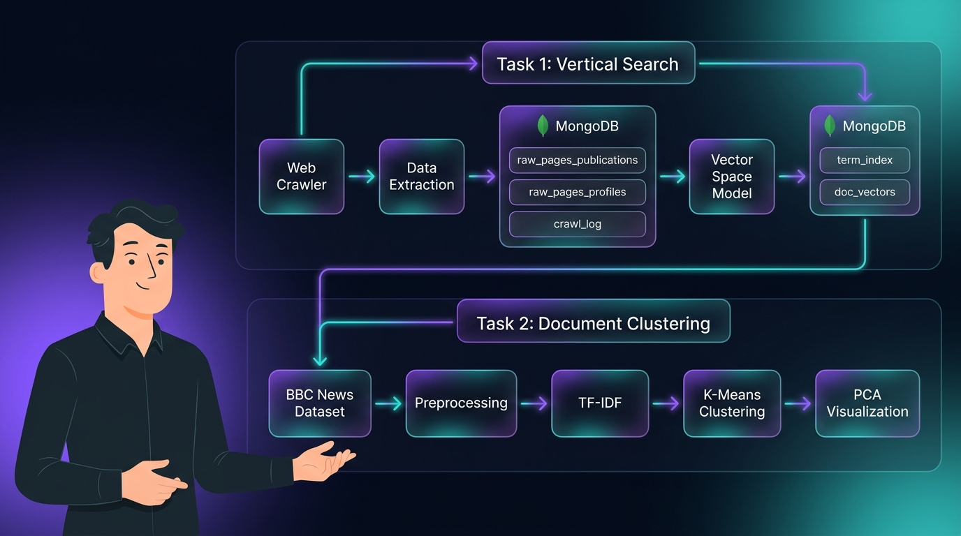
Figure F1. Task 1 Architecture

F.2 Task 1: Vertical Search Engine
The following screenshots demonstrate the Task 1 search engine interface and results. The system indexes 80 research outputs and 117 author profiles from Coventry University's PurePortal.
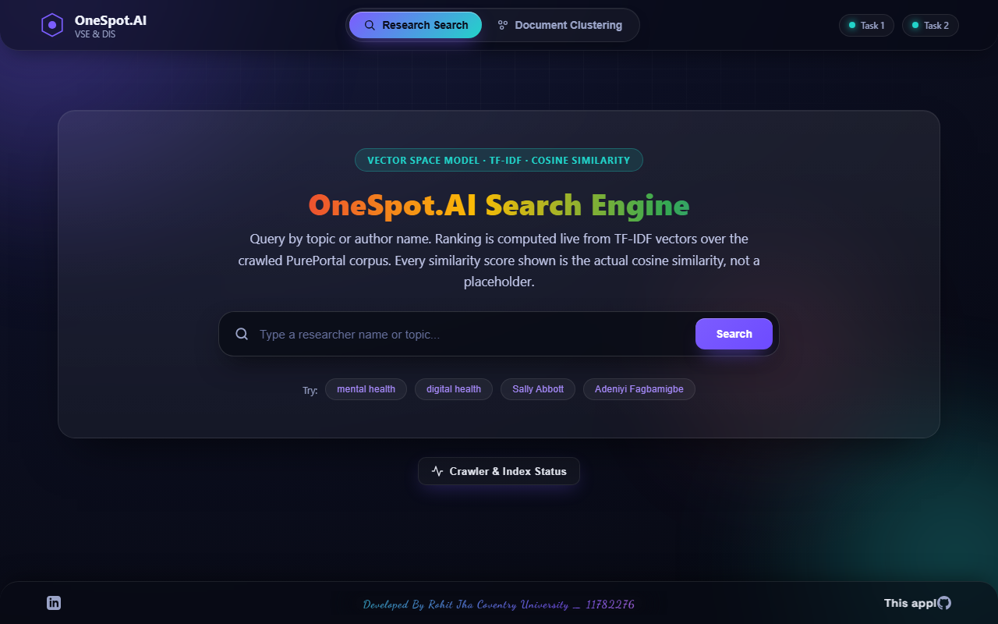
Figure F3. Unified Interface
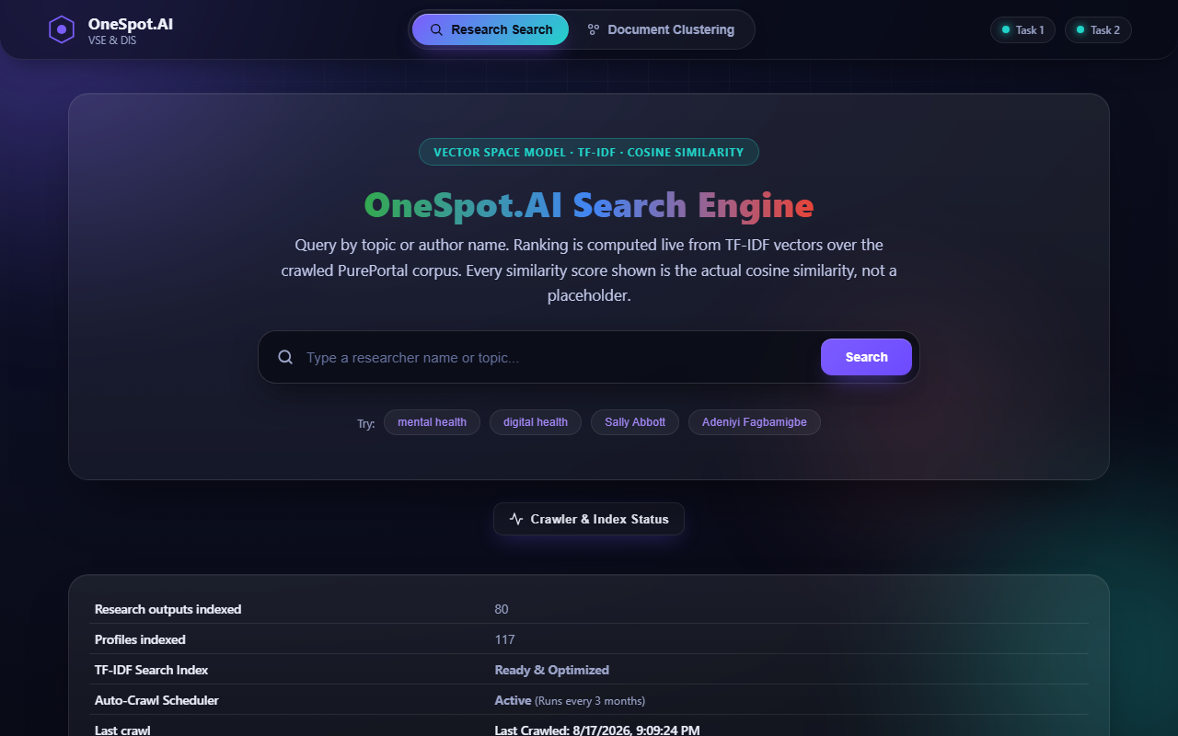
Figure F4. Live Crawler Status
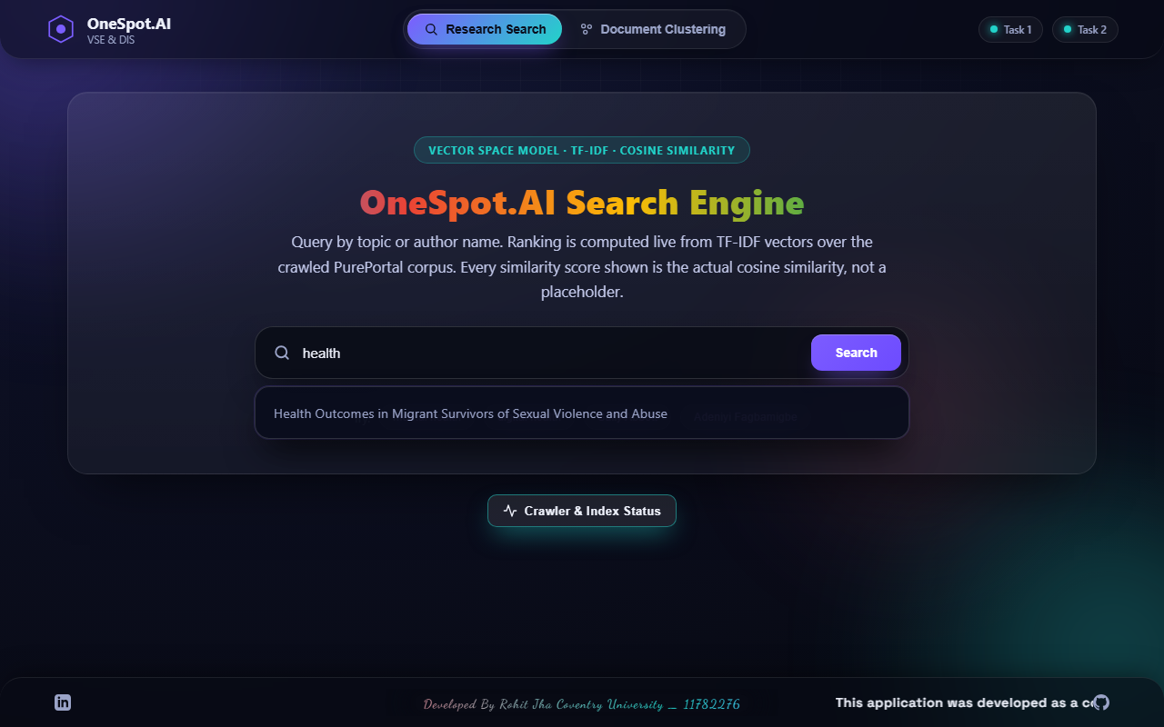
Figure F5. Auto-Suggestions
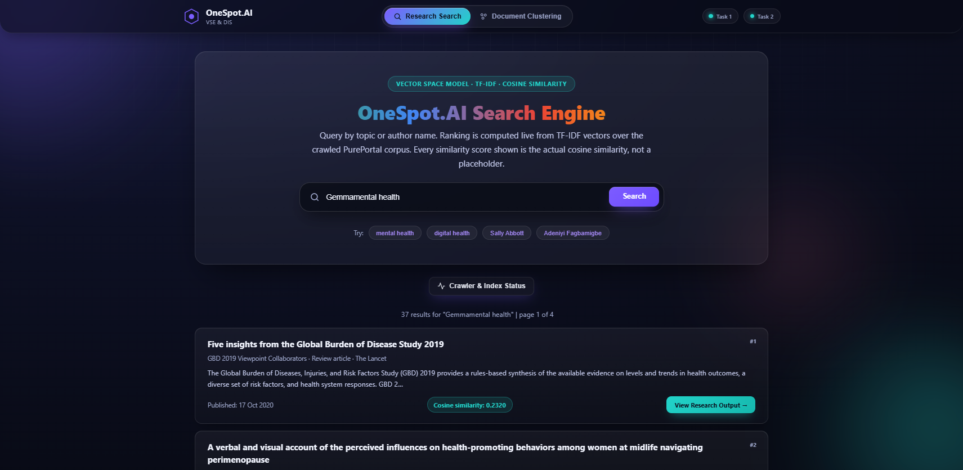
Figure F6. Search Results

Figure F7. Pagination

F.3 Task 2: Document Clustering
The following screenshots demonstrate the Task 2 clustering interface and results. The K-Means model (K=3) was trained on 540 BBC News articles.
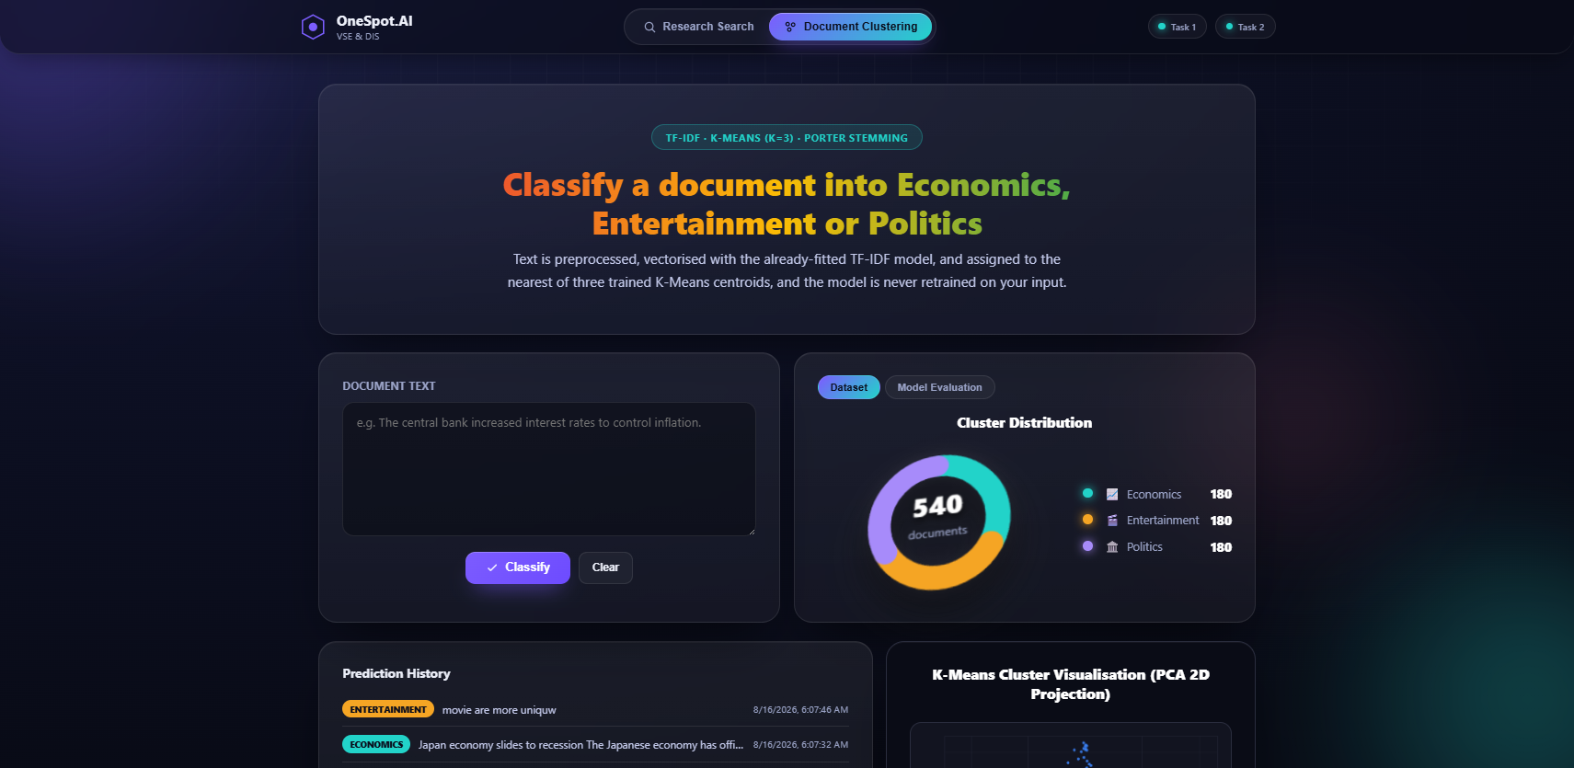
Figure F11. Document Clustering
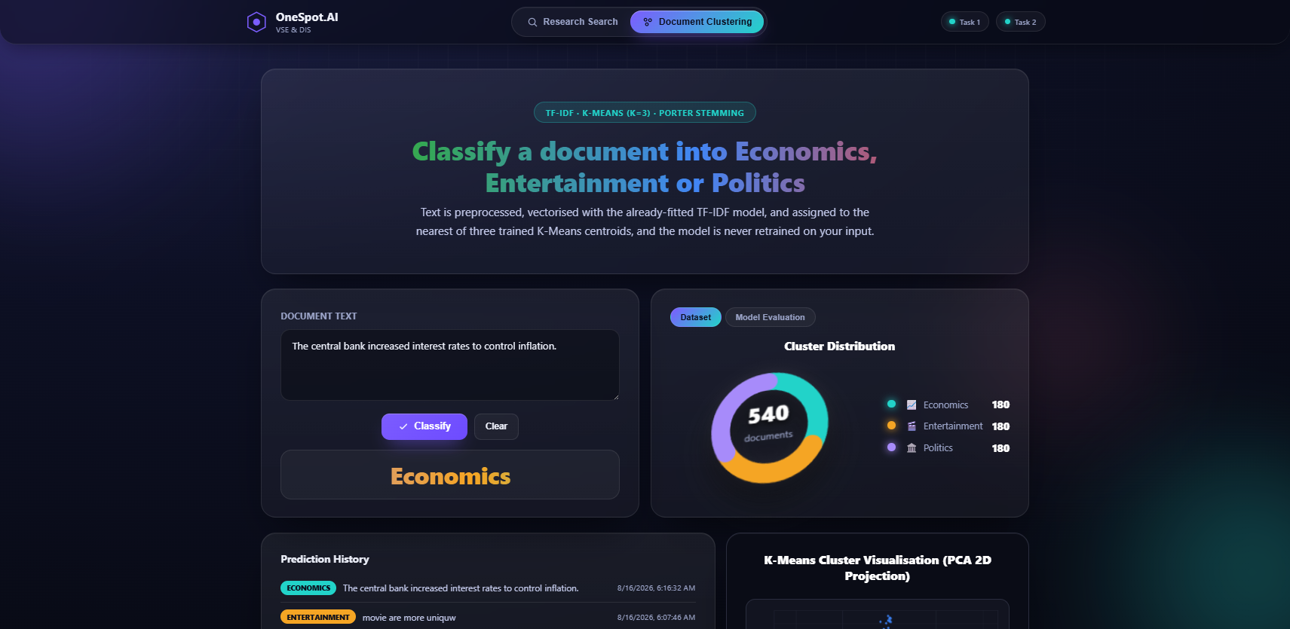
Figure F12. Classification
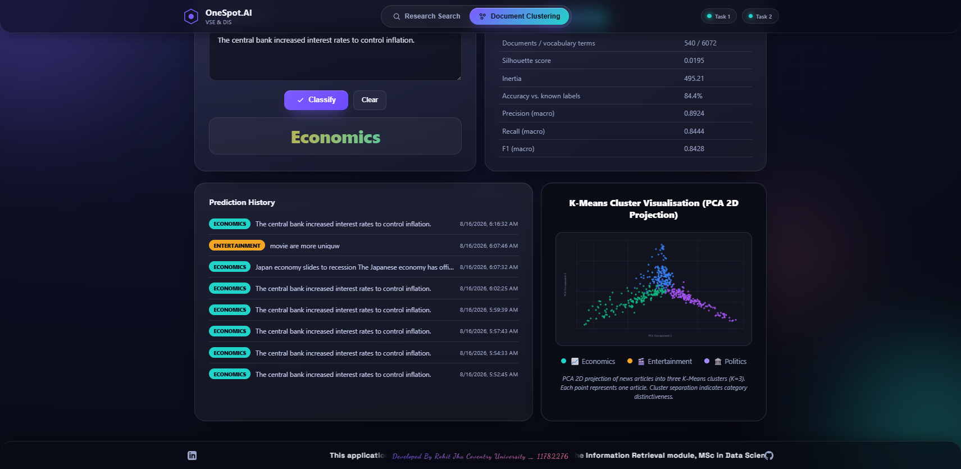
Figure F13. PCA 2D Cluster
Figure F14. Model Evaluation

F.4 Dynamic Cluster Assignment
The current clustering process identifies 3 clusters for the BBC News document corpus (Economics, Entertainment, and Politics). These values are dynamic rather than fixed. As new documents are added, the K-Means algorithm may produce different cluster distributions depending on the updated data distribution.

